

**Emergency Paid Sick Leave Act Guidance**

**As of 06/29/2020**

**Introduction:**

On March 18, 2020, President Trump signed into law the Families First Coronavirus Response Act (FFCRA), which also created the **Emergency Paid Sick Leave Act (EPSLA)** that providesemergency paid sick leave in response to the COVID-19 global pandemic. Effective April 1, 2020 through December 31, 2020, in accordance with the **FFCRA/EPSLA**, employees are entitled to up to a maximum of 80 hours (prorated for part-time employees) of fully or partially paid emergency sick leave under one or more of the 6 provisions below. This temporary, new form of leave is available in addition to any other paid leave entitlements.

**It is important to note that this provision is an entitlement – and as such – if an employee requests this leave and has the appropriate documentation, supervisors should approve the request(s).**

**Relationship to Mandatory Pandemic Telework:**

It is important to note that under the declared mandatory pandemic telework, all employees are in a mandatory telework status and are not using their leave unless:

* They prefer not to telework and are on approved Annual Leave or Leave Without Pay (LWOP); or
* They are sick and are on approved Sick Leave, Annual Leave, or LWOP.
  + ***However, if the illness is COVID-19 related, use of EPSLA leave could be considered***.

Depending on the circumstances, employees are currently being paid with pandemic telework, routine telework and administrative leave. This includes and allows for employees and supervisors to work together to provide flexibility in work schedules due to family responsibilities. Under these circumstances (except illness) you **are** able to telework at this time, therefore in **most cases EPSLA leave is not applicable**.

Employees should exercise caution in prematurely invoking EPSLA leave. Once the pandemic and mandatory telework are lifted, these EPSLA provisions could be very beneficial.

**Eligibility**:

All HUD employees, regardless of their length of service that are **unable to work OR telework** subject to the provisions identified below.

**Provisions:**

**Under the following situations, employees with the appropriate documentation may be paid** at the **full rate of pay** for up to 10 days/80 hours, subject to daily and aggregate pay caps. This is effective from April 1, 2020 – December 31, 2020, if the employee is **unable to work, including unable to telework**, due to one of the following situations.

1. Is subject to federal, state, or local quarantine or isolation – not stay at home order - related to COVID-19;
2. Has been advised by their doctor to self-quarantine due to COVID-19; or
3. Is experiencing symptoms of COVID-19 and is seeking a medical diagnosis.

**Under the following situations, employees with the appropriate documentation may be paid at only** **2/3 the rate of pay** for up to 10 days/80 hours, subject to daily and aggregate pay caps. This is effective from April 1, 2020 – December 31, 2020 **if the employee is unable to work, including unable to telework**, due to one of the following situations.

4. Is caring for a family member subject to a quarantine order or self-quarantine.

1. Is caring for children if schools are closed or their caregiver is unavailable because of the COVID-19 health emergency; or
2. Employee is experiencing any other substantially similar condition specified by the Secretary of Health and Human Services, in consultation with Secretaries of Labor and Treasury. (These conditions are to be determined as the DOL issues implementing guidance.)

Employees must be aware that invoking ELPSA for these situations may require a different form of paid/unpaid leave to be entered for any hours in excess of the cap. **Examples of a 5/4/9 compressed work schedule:**

Example One - An employee needs to be isolated and cannot work/telework due to COVID-19; the employee will code their timecard with the required code.   
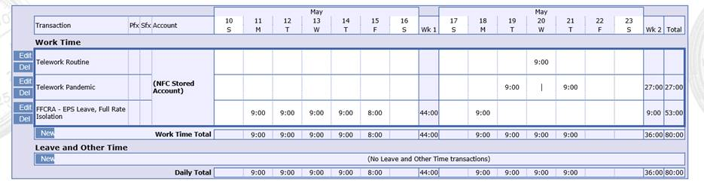

Once the timecard has been validated; payroll reviews the record to verify if the employee has reached their daily maximum rate of $511.  It has been discovered after 7 hours each day, the employee reached their cap.  The payroll office notifies the employee and the webTA will be adjusted to add personal leave to make up the difference. The employee will use other paid leave for the remaining hours each day the employee is out from work due to COVID-19.

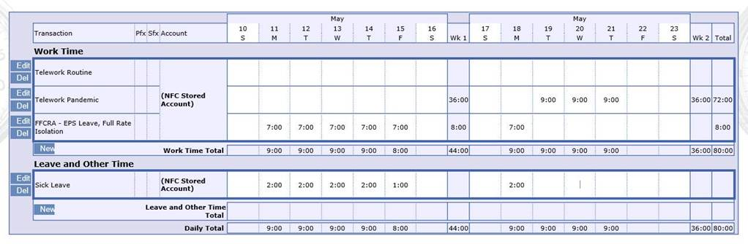

Example Two - An employee is unable to telework due to childcare (school closure due to COVID-19); and the payroll office has determined that the employee has reached their $200 maximum rate after working 4 hrs.  The employee is advised to use other paid leave for the remaining hours each day the employee is out due to childcare under COVID-19.

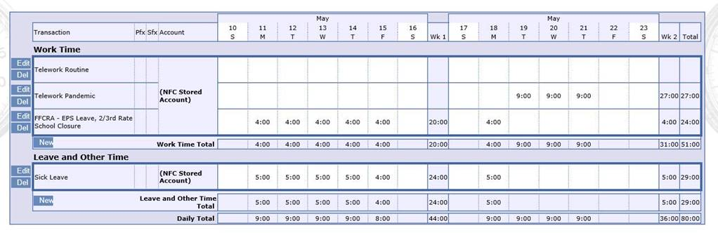

Note: Definition of a Health Care Provider can be found at 29 CFR § 825.102.

Corrections may be made to WebTA to replace any other leave (annual leave, sick leave, LWOP, etc.) that was taken with (qualifying) EPSLA leave starting April 1, 2020 and after.

**Payment for Leave:**

The amount of pay for EPSLA paid sick leave depends on the employee’s hourly rate and the hours of leave used. The hourly rate payable for EPSLA paid sick leave is based on an employee’s average hourly regular rate determined under the Fair Labor Standards Act (FLSA) or two-thirds of that rate (subject to daily and aggregate limits), depending on the applicable qualifying circumstance.

The number of hours of EPSLA paid sick leave that may be used on a workday is generally based on the employee’s established tour of duty for leave charging purposes. Daily and aggregate limits on pay for EPSLA paid sick leave are described below.

For qualifying circumstances #’s 1, 2, and 3, (listed above) EPSLA paid sick leave is paid at an hourly rate equal to an employee’s average FLSA-based hourly regular rate.

For qualifying circumstances #’s 4, 5, and 6, (listed above) EPSLA paid sick leave is paid at an hourly rate equal to two-thirds of an employee’s average FLSA-based hourly regular rate.

o **Average FLSA regular rate**. An employee’s average FLSA-based hourly regular rate is calculated based on the following: Using the methods provided in 29 U.S.C. 207(e) and 29 CFR parts 531 and 778 to compute the regular rate for each full workweek in which the employee has been employed during the 6-month period ending on the day on which EPSLA paid sick leave is first used or if the employee has been employed by the employer for less than 6 months, during the entire period of employment.

o Computing the average of the weekly regular rates derived above, weighted by the number of hours worked for each workweek.

**Daily and aggregate limits**. The pay received by an employee for EPSLA paid sick leave under the hourly rates specified above may not exceed the following daily and aggregate limitations below:

* $511 per day and $5,110 in the aggregate for one or more of the qualifying circumstances #’s 1, 2, or 3.
* $200 per day and $2,000 in the aggregate for one or more of the qualifying circumstances #’s 4, 5, or 6.

**NOTE REGARDING AGGREGATE LIMIT**: EPSLA leave taken for qualifying circumstances #’s 4, 5, and/or 6 also counts towards the $511 daily limit and the $5,110 aggregate limit. For example, an employee who has already received $2,000 in paid sick leave to take care of his or her child would only have $3,110 left to take paid sick leave to self-quarantine. Employees with higher rates of pay are more likely to reach the daily limit. In the case of leave used for an 8-hour workday, the $511 daily limitation would be exceeded if the employee’s hourly rate exceeds $63.87 and the $200 daily limitation would be exceeded if the employee’s two-thirds hourly rate exceeds $25.00 (i.e., the full hourly rate exceeds $37.50).

**Timekeeping:**

The National Finance Center has now updated webTA to include the EPSLA leave flexibilities. Therefore, employees may enter their ELPSA leave requests in webTA. If the employee is unable to do so, your timekeeper must enter the needed hours and identify if an employee reaches the pay cap.

Note: The timecard must be validated/certified NLT Tuesday after the pay period closes.  Employees must ensure they are using the proper codes for which they have the appropriate documentation and received supervisory approval to use EPSLA paid leave.  Corrected T&As and/or late submissions of T&A’s may result in a salary overpaymentand will result in a debt to the Federal service*.*  Employees are expected to return any overpayments.

**Approval and Documentation:**

**Approval.** Employees must give notice to **(and obtain approval from)** their supervisors of the need to take EPSLA leave and must provide supporting documentation for requests for paid sick leave.

**Documentation.** An employee is required to provide the employing agency with documentation containing information to support the taking of EPSLA paid sick leave.

a. General Information Required:

(1) Employee's name.

(2) Date(s) for which leave is requested.

(3) Qualifying COVID-19-related reason for the leave; and

(4) A statement that the employee is unable to work and describes the qualifying COVID-19-related reason for leave under EPSLA.

* An optional checklist is provided for your convenience.

b. To take EPSLA paid sick leave for qualifying circumstance #1, an employee must additionally provide the employing agency with the name and documentation of the government entity that issued the quarantine or isolation order. NOTE: Quarantine or isolation orders are different than stay-at-home orders.

c. To take EPSLA paid sick leave for qualifying circumstance #2, an employee must additionally provide the employing agency with the name and documentation of the health care provider who advised the employee to self-quarantine due to concerns related to COVID-19.

d. To take EPSLA paid sick leave for qualifying circumstance #3, the name of the healthcare provider and the date of my medical appointment.

e. To take EPSLA paid sick leave for qualifying circumstance #4, an employee must additionally provide the employing agency with either:

* The name and documentation of the government entity that issued the quarantine or isolation order to which the individual being cared for is subject; or
* The name and documentation of the health care provider who advised the individual being cared for to self-quarantine due to concerns related to COVID-19.

f. To take EPSLA paid sick leave for qualifying circumstance #5, an employee must additionally provide:

(i) The name of the son or daughter being cared for;

(ii) The name of the school, place of care, or childcare provider that has closed or become unavailable due to COVID-19; and

(iii) A representation that no other suitable person will be caring for the employee’s son or daughter during the period for which the employee takes EPSLA paid sick leave.

**Other Information:**

**Retroactive use**. An employee may request, and an employing agency must grant, EPSLA leave for which the employee is eligible to cover a past period of sick leave, annual leave, LWOP, etc. occurring during the period of April 1, 2020, through December 31, 2020. Employees may request corrections to their timecards to substitute EPSLA leave for personal leave that was used prior to the issuance of this guidance. The request must be made no later than 45 days from the release of this guidance. For clarity, substitution of personal leave with EPSLA leave taken between **April 1, 2020 and June 29, 2020, must approved and submitted no later than August 13, 2020.**

**Employee right**. An employee has the right to use EPSLA paid sick leave before using other paid leave available to the employee. An employing agency may not interfere with this right.

**No payment for unused leave**. An employee must use EPSLA paid sick leave to receive payment for it. EPSLA does not require or authorize an unused amount of available EPSLA leave to be converted to a cash payment or any other reimbursement to the employee upon separation from agency employment or expiration of EPSLA on December 31, 2020.

**ATTENTION MANAGERS:**

**Recordkeeping**. An employing agency is required to retain all documentation provided by the employee (see 29 CFR 826.100 and 826.140) ***for four (4) years, regardless of whether leave was granted or denied***. If an employee provided oral statements to support his or her request, the agency is required to document and maintain such information in its records for 4 years.

Employees should be immediately advised to enter all EPSLA leave hours in webTA as soon as possible. The employee may need the assistance of the timekeeper if the employee is unable to enter the hours. The list of HUD timekeepers can be found below:

[Headquarters Timekeepers](http://hudatwork.hud.gov/HUD/chco/doc/hqtimekprs_30817.docx)

[Field Timekeepers](http://hudatwork.hud.gov/HUD/chco/doc/fieldimekeepers)

For assistance with properly recording absences to the webTA T&A, please contact the Payroll Call Center at (304) 480-8400. Any additional questions may be submitted to [PBRD@hud.gov](mailto:PBRD@hud.gov).