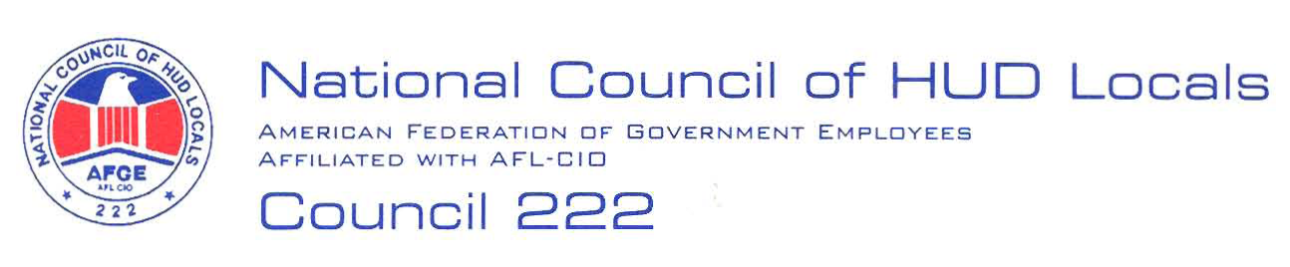

January 12, 2009

MEMORANDUM FOR: Norman Mesewicz, Deputy Director, Labor Employee
Relations Division, ARHL

FROM: Lisa A. Lowery, Chair, Midterm Bargaining Team, AFGE Council
Of HUD Locals 222

SUBJECT: Removal of Personal Appliances

This will serve as AFGE Council of HUD Locals 222 demand to bargain the
proposed subject Management initiative. Below is our preliminary proposal:
No Adverse Impact: The subject Management initiative shall have no adverse impact on any bargaining unit employee.
This is a preliminary proposal only, and the union reserves the right to bargain or amend or add proposals, in accordance with Article 5. Russell Varnardo, President, or I will notify you of the selection of the Chief Negotiator.

