Resolving Incidents in Right Now

Live Telephone Incidents

- The FHA Resource Center will transfer the incident in the Right Now system and transfer the caller to you.
- Obtain the incident in the “My Inbox” section of the Support Console – double click to open
- Review client information in the Contact tab, the issue in Messages tab, and property information in the Details tab.
- Provide comments on resolution Messages tab – make sure the “Customer Entry” button is filled in. Customer Entry should be used for all telephone contacts.
- Was the contact properly escalated? If not update that field in the Details tab
- Is the contact response eligible for the Knowledge Base? If so, click on the “Propose” button in upper right hand corner.
- If you need to reassign the contact, use the Assigned field to reassign to a group or individual.
- Prior to saving, make sure you update the Status field. Select “Waiting” if you need more information before completion, or “Resolved” if you are all done.
- Don’t forget to Save!!
- Want to check on the incident after saving? Check the “My Incidents” area.

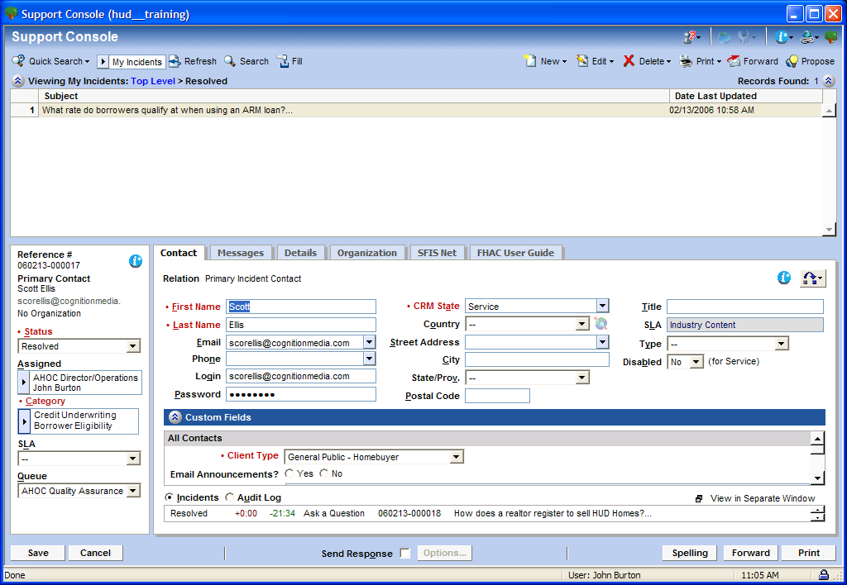
7
6
5
3
9
8
2

Electronic Mail Incidents

- FHA Resource Center or your management chain will transfer the incident in the Right Now system.
- Obtain the incident in the “My Inbox” section of the Support Console – double click to open
- Review client information in the Contact tab, the issue in Messages tab, and property information in the Details tab.
- Provide comments on resolution Messages tab – make sure the “Response” button is filled in for e:mails.
- Was the contact properly escalated? If not update that field in the Details tab
- Is the contact response eligible for the Knowledge Base? If so, click on the “Propose” button in upper right hand corner.
- If you need to reassign the contact, use the Assigned field to reassign to another group or individual.
- Prior to saving make sure you update the Status field. Select “Waiting” if you need more information before completion, or “Resolved” if you are all done.
- If you are e:mailing a response, verify the e:mail address is in the Contact tab and check the “Send Response” box at the bottom of the page.
- Don’t forget to Save!!
- Want to check on the incident after saving? Check the “My Incidents” area.

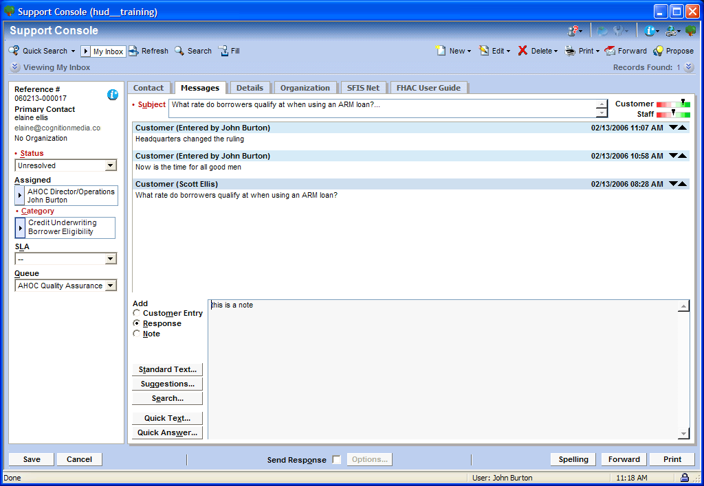
9
4

