RightNow Technologies
Customer Relationship Management (CRM) Tool
Homeownership Center Training Workbook

U.S. Department of Housing and Urban Development (HUD)
Office of Single Family Housing
FHA Resource Center

Prepared by:


Electronic Consulting Services, Inc. (ECS)
2750 Prosperity Avenue
Suite 510
Fairfax, VA 22031
Table of Contents

1: Introduction to the FHA Resource Center 1
FHA Resource Center Requirements 1
FHA Resource Center Solution 3
Support Tiers 4
Warm Transfers 5
Phased Approach 6
Project Organization and Key People 7
Points of Contact 8
2: RightNow Service Overview 9
Introduction to Service 9
Course Objectives 9
Login Information 10
3: Navigating the Session Console 11
Objectives: 11
Key Terms: 11
Lesson 1: Session Console Toolbar 12
Lesson 2: Deleting a message 13
Lesson 3: Changing the Password 14
4: Support Console 15
Objectives: 15
Key Terms 15
Lesson 1: Introduction to an Incident Process 17
Lesson 2: Introduction to the Support Console 18
Lesson 3: Working an Incident: The Bare Essentials 19
Lesson 4. Skills Practice 20
Lesson 5: Case Studies 21
Lesson 4: Working with Views 24
Lesson 5: Working Phone Call Incidents 25
Lesson 6: Replying to Email/Fax Incidents 28
Lesson 7: Replying to an Ask A Question Incidents 29
Lesson 8: Proposing Answers 31
5: Answers Site 32
Objectives: 32
Introduction 32
Key Terms: 32
Lesson 1: Introduction to the HUD Answers Site 33
Lesson 2: Searching the “Answers Site” Knowledge Base 35
Lesson 3: Ask a Question 36
Lesson 4: “My Stuff” Tab 38
Appendix : Support Console Tab and Field Definitions: 39

1: Introduction to the FHA Resource Center

FHA Resource Center Requirements

FHA Resource Center Solution

Support Tiers

Warm Transfers

Phased Approach

Project Organization and Key People

Points of Contact

2: RightNow Service Overview

Introduction to Service
RightNow Service provides an easy-to-use customer service and support solution that intelligently assists both customers and agents with inquiry resolution across traditional and online channels. You can easily capture, respond to, manage, and track all service interactions in one consolidated application that optimizes agent efficiency and enables you to proactively manage customer relationships.

Course Objectives
By the end of this workbook, you should be able to:
- Navigate the Answers web site pages
- Navigate the Session Console
- Log Phone Calls, Voicemail, Postal Mail, Voicemail and Faxes
- Respond to Email and Ask A Question incidents from the Answers site
- Update contact and organization information

Login Information
Logging into RightNow Service is easy.

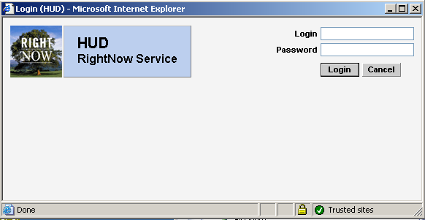

- Enter the URL to access
- Answers site URL: HUD. Custelp.com
- Support URL: hud.custhelp.com/cgi-bin/php/admin/session/login.php
- Enter the username and password in the fields on the Login screen.
- Login: _____________________________________
- Password: We recommend you don’t write down your password! Memorize it and keep it safe!
- Press the Enter key or select the Login icon.

3: Navigating the Session Console

Objectives:
- Understand the Session Console
- Understand Personal Settings
- Navigate the Support application

Key Terms:
CRM – Customer Relationship Management is the genre of this type of application. It is used to manage incidents and information dispersal to large customer bases throughout government and commercial industries.

Administration interface—The administration graphical user interface that includes consoles, panels, and windows used to administer RightNow Service.

Customers—borrowers and lenders that contact HUD with questions

CSR—Customer Service Representative: A staff member who may be assigned incidents and Live chats with borrowers and lenders (customers), and who may also maintain contact and organization records.

Command area—The area on the left side of the toolbar containing buttons for performing actions specific to the current window or console.

Console—A major window in RightNow Service where administrators, agents, and other staff members can access and work with RightNow Service. Consoles include Session, Support, Live, Answer, Analytics, and Management and Configuration.

Inbox—An agent’s personal queue. The inbox contains all incidents that have been pulled from a queue or multiple queues, and are currently assigned to the agent.

Incident—Any question or request for help from an end-user through Ask a Question or email inquiries, Live chat sessions, site or answer feedback, or inquiries from external sources using RightNow Service’s published application program interface. Incidents can also be added by agents in the Support Console.

Navigation area—The area on the right side of the toolbar containing buttons for accessing other consoles, Help, and the Links menu.

Toolbar—The bar across a console or window in RightNow Service containing buttons for performing functions and accessing consoles, modules, help, and links in RightNow Service.

Lesson 1: Session Console Toolbar
Objective: Light to moderate familiarity with the Session Console.

The session console contains valuable information that can help you perform your duties as an agent, manager, or administrator. Depending on access you may see all Queues in the system, queues assigned to your profile, or no queues. All users will see the message notification pane.

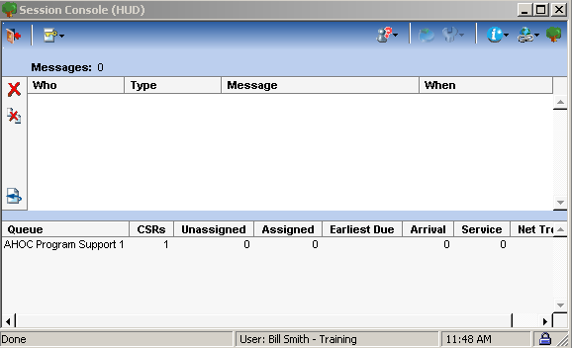
Navigation Bar:
Logout – Be sure to use this icon/button to exit the system.
Preferences - password change and default screens setup.
Support Console – leads to support console or the answers console.
i button – provides documentation about the CRM support system
Links – links to resources such as the knowledge base “Answers” web site.

Queue Stats – shows various counts that allow a rep to gauge activity

Lesson 2: Deleting a message
Objective: Learn the purpose of this screen

Notification messages are sent for multiple reasons within the RNT Application. For an example, when an incident is reopened by another staff account, when an incident is assigned to you, or when an incident has been reassigned.

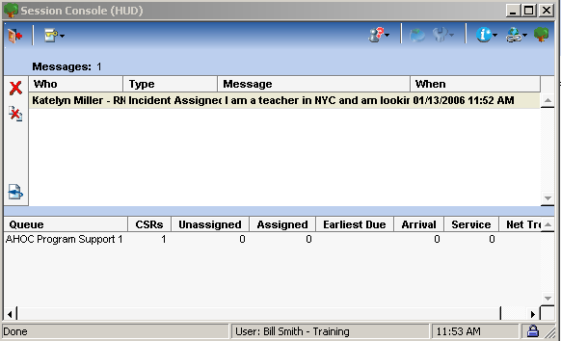
Activities:
- Select a Message in the Message Pane, and click the Delete icon.
- Select the Refresh icon to see new messages.
Discussion Points:
- Deleting a message does not delete the incident associated to it.

Lesson 3: Changing the Password
Objective: Changing the password

Personal Settings provides access to changing passwords and setting up start console, country, email notifications, or the option to be notified always.

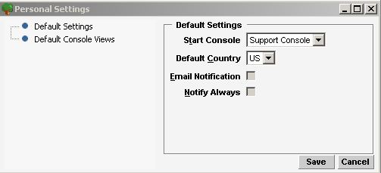

Activities:
- Click the Personal Settings icon > Change Password to view function.

- Select the Personal Settings button > Personal Settings. Select Default Settings > Support Console from the Startup Console.

3. Log out and log back in to see this feature in action.

Discussion Points:
- How do you log out?

- What happens when you log out? Does it close all open consoles?

- Do you have the option of selecting default views for specific consoles?

4: Support Console

Objectives:
- Understand the work flow
- Reply to incidents
- Understand required fields
- Manage incident
- Comfortably navigate an incident and its tabs and fields

Key Terms
Representative—A staff member who may be assigned incidents and Live chats with end-users, and who may also maintain contact and organization records.

Inbox—A representative’s personal queue. The inbox contains all incidents that have been pulled from a queue or multiple queues, and are currently assigned to the agent.

Incident—Any question or request for help from an end-user through Ask a Question or email inquiries, Live chat sessions, site or answer feedback, or inquiries from external sources using the “Answers” web site. Incidents can also be added by agents in the Support Console.

Incident Side panel: Display portion to the left of the tabs section that shows key incident fields such as Queue, Status, Assigned, and SLA

Organization—Any company, business unit of a large company, or government agency that has an organization record in the knowledge base. Organizations can have SLAs with custom levels of answers assigned to them so that contacts associated with the organizations can view privileged access answers.

Support Console—The console for adding, editing, viewing and responding to incidents, and adding and maintaining contact and organization records. The Support Console tracks all incidents generated by end-users through any source. Also called agent interface.

Tab Set: Contains incident information, contact, organization fields, and custom tabs.

Toolbar: Contains both the command and navigation areas located in both rows. To the left of the second row are the command buttons for the view grid and to the right is the command area for the tab set.

View—A unique display of information customizable for the Support and Answer Consoles and end-user search pages, including the Find Answers page and the My Stuff—Questions page. A view specifies the search options available (fixed and run-time selectable filters) used to select particular groups of answers and incidents, and the output columns that will be displayed.

View grid—The output columns of the currently selected view on the Answer and Support Consoles, and the Find Answers page on the end-user interface.

Lesson 1: Introduction to an Incident Process
This workflow applies all incident types: Phone, Email, Ask A Question, Fax, Postal Mail, and Voicemail.

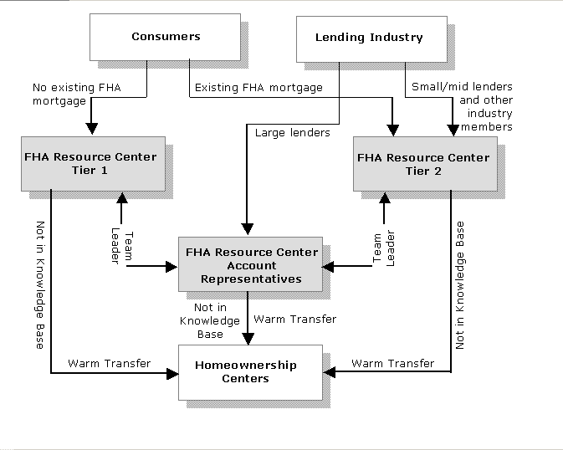

Lesson 2: Introduction to the Support Console
Objective: Light to moderate understanding of the support console features and functions.

The Support Console assists you in managing and solving incidents, and maintaining organizations and contacts in the knowledge base, while providing your customers with effective and timely customer service and support. For our first example we are going to start with a basic phone call.

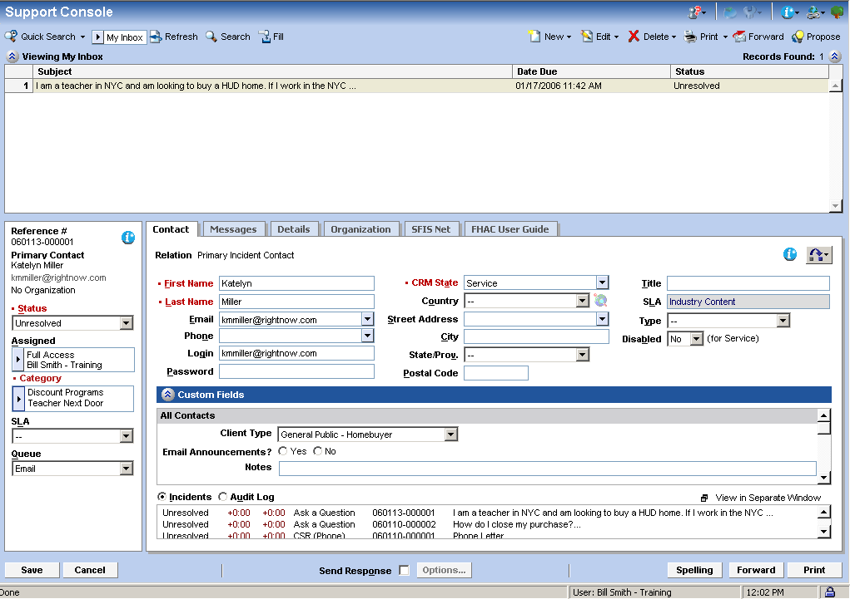
From this screen, all incidents may be managed and resolved. The next several lessons will drill you in how this screen will be used to respond to five different types of incidents:
  - Phone Call
  - Email
  - “Ask a Question”
  - Fax
  - Voice message

Lesson 3: Working an Incident: The Bare Essentials
Objective: Light familiarity with reviewing and resolving an incident.

The following steps in this lesson are a basic procedure which will provide a foundation for further learning. Repeat this lesson with two to three incidents.

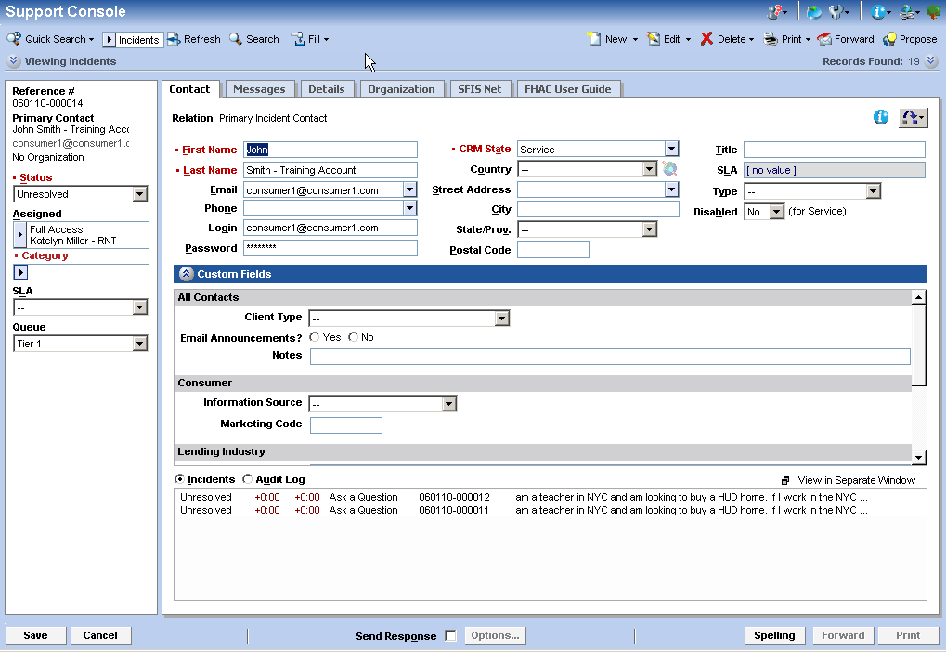
  - Call is transferred and FHA Resource Customer Service Representative provides the incident number.
  - Click on Refresh Button. The view should be “My Inbox”.
  - If the other end has saved the incident and assigned it properly, it will appear in your queue.
NOTE: Since this is a training environment, this will not work like this because there isn’t really someone on the other end assigning a call to you. Your incidents should already be assigned to you.
  - Verify with the customer that you have the right person.
  - Click on the message tab and review the Incident subject.
  - Type in an answer, change the status to resolved, and Save.

Lesson 4. Skills Practice
Objective: Learn how to create a new incident and a new contact.

New Skill: Associate a contact

Working with Phone Incidents
A variety of incidents are handled in a slightly different manner. The following exercises review phone incidents.

Instructions: Create a New Contact for each of the following incidents and apply each step of the Basic Incident Process using the Support Console. Follow along with the instructor as he or she guides you through these steps. If you run into a difficulty, make yourself heard! Feel free to speak up!

1. “I want to check on the status of my waiver on well and septic distance.”

2.“ I have an identity of interest sale on a 203K mortgage and I want to know if I need to get 2 appraisals.

3. “I am calling from Congressman XXX's office, and he would like to know about HUD's marketing plans in Baltimore.

Note: Refer back to your 6 Bare Essentials from Lesson 3 for the handling and status adjustment of each of these practice items.

Lesson 5: Case Studies

HOC Case Studies

Case #1

Summary
You have just received a warm transfer from the FHA Resource Center. John Lightfoot is calling in from a Reservation in Arizona. All of his life he and his family have been renting their home. John has worked hard in his career in education and has saved and invested his money well. He is now interested in purchasing property and a home. He and his family have very strong ties to the Reservation. In fact John is a well respect and very active civic and community leader. He is particularly interested in purchasing a home on tribal land.

John has called the 800 number to receive information about what programs may be available for Native Americans on Tribal Land.

How would you handle this call?

New Skill: Add a note to this call.

Case #2

Summary
Lisa Smith considers herself pretty savvy on the internet. So when she had a question as a current Homeowner, she decided to go the “Ask A Question” website to get some answers. Lisa is single and her mother who is disabled recently moved in with her. She recently found out that her home needs the roof replaced and will require a ramp for her Mom to be able to access the house. The home rehabilitation costs are estimated to be about $10,000.00.

Lisa searched the ‘Ask a Question” site and although she found a wealth of information she didn’t get the answers that she was looking for. So she has submitted the following question on-line:

“What is the FHA Rehabilitation Mortgage Program?”

The FHA Resource Center Tier 1 representative has forwarded this question to the Account Representatives. They in turn have forwarded the question to the HOC, stating the answer could not be found in the Knowledge Base.

How would you respond?

New Skill: Sending a response that is an email. Understand the difference between “Customer Response”, “Response”, and “Note” fields. Understand that the radio button selects between different fields.

Case #3

Summary
Bob Bailey is a conscientious man. He prides himself on always having all of his affairs in order. He has a current FHA mortgage and is interested in paying it off early. Bob called the 800 number to find out where he could obtain information on prepayment penalties for FHA mortgages.

When the Tier 1 representative received his call, the Knowledge Base instructed the representative to have the caller referred to the FHA National Servicing Center. Bob was transferred to the HOC

How would you handle this call using the Support Center Console?

New Skill: Search the knowledge base for this answer using the “Search” feature. Mark the item as “escalated appropriately.”

Lesson 4: Working with Views
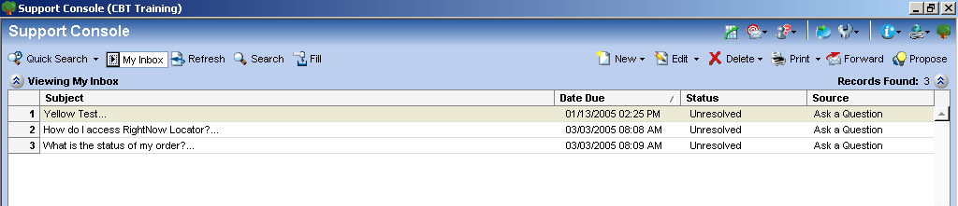

The view grid displays the output columns of the currently selected views. A view determines which fields are displayed, the order of the fields displayed, and how the records are sorted. Any field can be included in the output, including incident contact and organization fields. The six default views for the Support Console include My Inbox, My incidents, Today’s Incidents, Incidents, Queues, Contacts, Organizations and Groups. The search and selection criteria defaults vary from one Support Console view to another. My Inbox and My Incidents Views are available for each CSR. Dependent on position other Views may be available.

Activities:
- Select the My Inbox View, which displays all your unresolved and updated incidents.

- Select My Inbox View. Next, click the Search icon. Take a look at the search fields. Now select a different view, and click the Search icon. As you can see, the search criteria are dependent on your view.

- Select the My Incidents View, and search for all your Resolved incidents.

- Using the Quick Search, find the incident you submitted this morning.

Discussion Points:

- Representatives can not create their own views.

- The Incident Quick Search saves a list of the last 10 incidents that you have worked on.

- Escalated incidents appear in blue on the Support Console (all views have been updated). Incidents escalate regardless of type (Postal Mail, Email, Chat, Fax, Answer Feedback, Ask a Question). Incidents escalate if they are unresolved or Updated and 11 hours have passed since incident creation.
All incidents that are Unresolved or Updated and 24 hours old or older appear in red on the Support Console. All views have been updated.

Lesson 5: Working Phone Call Incidents
This lesson will explore the basic steps to working a phone call incident.

Phone Call Scenario:
Caller would like to know how to become a HUD Counselor
- Call is transferred and is assigned to an available HUD counselor. The incident number and contact information is provided by FHA Resource Agent: The HUD Counselor gives Agent their name
- Select Incident; incident populates as shown below:
- Verify Incident Subject: HUD Counselor.
- Verify Customer Entry Caller would like to know how to become a HUD Counselor.
- In the Message Tab; Select the Search button to search the knowledge base for the answer to the Consumers question. Type in the following for the search text: “HUD Counselor” and select Search. Verify KB Answer doesn’t exist.
- Select Details Tab to update necessary custom fields.
- Select Contact Tab to update necessary custom fields.
- Select Resolved for incident status.
- Assign Category appropriate categories.
- Select Save to complete this incident.
Phone Call Scenario 2:
Caller would like to know, “Can the lender collect from the borrower amounts advanced for a required principal reduction?” Caller also wished to remain anonymous.
1. Call is transferred and is assigned to an available HUD counselor. The incident number and contact information is provided by FHA Resource Agent: The HUD Counselor gives Agent their name
2. Select Incident; incident populates as shown below:
3. Select the Message Tab > Enter Subject: Principal Reduction.
4. Select the Message Tab > Enter Customer Entry Caller, “Can the lender collect from the borrower amounts advanced for a required principal reduction?”
5. From the Message Tab; To verify a KB answer doesn’t exist, select the Search button to search the knowledge base for the answer to the Consumers question. Type in the following for the search text: “borrower advanced principal reduction” and select Search. Verify Answer doesn’t exist.
6. Answer does exist; “Can the lender collect from the borrower amounts advanced for a required principal reduction?”
7. Append Answer Text to the Customer Entry.
8. Select Note radio button to add an internal note.
9. Select Details Tab to update necessary custom fields, Update HOC Only – Escalated Properly Custom Fields.
10. Select Contact Tab to update necessary custom fields.
11. Select Resolved for incident status.
12. Assign Category > Credit Underwriting > Assets and Funds to close> Gift Funds.
13. Select Save to complete this incident.
Discussion Points:

- Once a note is saved to the discussion thread, can it be deleted?
- How do you update contact information?
- Where can you find the name of the person who previously owned the incident assigned to you?

Lesson 6: Replying to Email/Fax Incidents
Objective: This lesson will explore the basic steps to replying to an email/fax incident. We will update the incident status, review customer history, add internal notes and use standard text with our reply.

Email Scenario 1:
James Adams would like to know, “How do I buy a HUD foreclosed home?”
- Click on the Fill Inbox Button.
- Click on the Contacts Button on the Toolbar >Select the My Inbox View; right-click an incident in the view grid, and select Edit Incident > Messages to activate the message tab with this incident’s information.
- Select Message Tab; review the incident discussion thread and information provided in the sidebar.
- From the Contact Tab, select the Incident radio button; right-click any of the incidents listed for the customer, and select View or Edit for additional information.
- From the Contact Tab, update all necessary contact custom fields.
- Select the Messages Tab; to verify a KB answer doesn’t exist, select the Suggestions button to search the knowledge base for the answer to the Consumers question. Type in the following for the search text: “buy HUD foreclosed” and select Search.

- Verify that a KB Answer does not exist.

- Click on the Response radio button to Compose Response.

- Click the Notes radio button and add an internal note. Customers cannot view notes. Notes can only be viewed externally when an incident is forwarded out of the system.

- Select the Details Tab; update all necessary incident custom fields.

- Select Resolved for incident status.

- Assign appropriate categories.

- Select the Send Response check box when you ready to send a reply.

- Click the Save button to send the reply to the customer.

Lesson 7: Replying to an Ask A Question Incidents
This lesson will explore the basic steps to replying to an Ask A Question incident. We will update the incident status, review customer history, add internal notes and use standard text with our reply.

Ask A Question Scenario 1:
Customer would like to know, “Does FHA allow unsecured loans to be used toward the down payment?”

New Skills: Viewing the audit trail and the session trail
- Click the Fill Inbox Button.
- Select the My Inbox View; right-click an incident in the view grid, and select Edit Incident > Messages to activate the message tab with this incident’s information.
- Select Message Tab; review the incident discussion thread and information provided in the sidebar.
- Select the Messages Tab; To verify an answer doesn’t exist select the Search button to search the knowledge base for the answer to the Consumers question. Type in the following for the search text: “unsecured loans down payment?” and select Search.

- Select the Answer “Does FHA allow unsecured loans to be used toward the down payment?” and review the content for the answer.

- Select Response button and compose response using KB Answer.
- From the Contact Tab, update all necessary contact custom fields.
- Select the Details Tab to review the Customers End-User Session.
- From the Details Tab, update all necessary incident custom fields.

- Click the Notes radio button and add an internal note. Customers cannot view notes. Notes can only be viewed externally when an incident is forwarded out of the system.

- Select Resolved for incident status.

- Assign appropriate categories.

- Select the Send Response check box when you ready to send a reply.

- Click the Save button to send the reply to the customer.

Discussion Points:
- What is the difference between an Incident Files and Response Files?
- Why can’t we see the Session Information for email incidents?
- Where do we view the Incident Source?
- If the Incident does have an available KB Answer, how do you classify it?
- Why is it important to check session information on an incident?

- How do you update contact information?

- What other ways might an incident become assigned to yourself?

- Where can you find the name of the person who assigned an incident to you?

Lesson 8: Proposing Answers
Proposing answers into the knowledge base is a powerful tool for agents. With the Propose Answer feature, you can propose answers from an incident, ensuring that the information your customers are inquiring about is the same information you are providing answers for.

- Highlight an incident, and click the Propose Answer icon. It is best to propose an Answer after the incident has been resolved since it provides all the information for the content manager.

- Click the OK button at the message prompt.

Discussion Points:

- Why is it important to propose answers into the knowledge base?

2. Incidents should be fully resolved before submitting an answer. Why?

5: Answers Site

Objectives:
- Navigate the “Answers” web site knowledge base and find answers
- Use “Ask a Question”
- Understand Key Terms and abbreviations
- Ask a lot of questions!

Introduction
The public facing Answers site combines knowledge base articles from several sources. From lender information to credit underwriting to foreclosure to auction, many topics are covered. However, some knowledge base articles may only be found in the internal knowledge base, only accessible by HUD support personnel.

In addition to serving as a frequently asked question (FAQ) site and a knowledge base site, the Answers site also serves as a “Questions” site. It provides the ability for a borrower or lender to “Ask a Question” that wends its way directly into the HUD support system. Such questions may end up in your inbox. This section will provide an overview of how users search the online knowledge base on the Answers site, and also how they “Ask a Question.”

Key Terms:
Browse—a search method on the end-user interface in which answers are grouped based on keywords, products, sub-products, categories, sub-categories, and noun phrases in the Summary and Question fields. Browse can be configured as single-level browse, which provides a guided search, or multi-level browse, which enables end-users to view the topic clusters of the knowledge base to find their own answers.

Complex expression—A search technique that enables end-users and staff to search for words or phrases when they know only a portion of them. This technique supports wildcard searching using an asterisk (*) at the end of a word or partial word. Word stemming and logical operators are supported. This technique is available on the end-user interface and the Answer and Support Consoles.

Logical operators—The symbols, (+) and (-), that can be used in most search techniques in RightNow Service to explicitly find answers that have a word (+) or that do not have a word (-).

Multi-level browse—An option in the Browse search method that provides end-users with a graphical interface similar to a file management system. End-users can navigate the knowledge base tree hierarchy to find answers. This search is designed for advanced users who know what they are looking for and want the freedom to view the topic clusters of the knowledge base to find their own answers.

Single-level browse—An option in the Browse search method that provides end-users with general topics they can choose from and then narrows to a specific answer. This option is designed for users who prefer to be guided through their search.

Text searching—A feature that enables end-users and staff members to search using their own words instead of choosing values from specific fields. The entered text is compared to the indexed keyword phrases for answers and keywords for incidents to locate similar keyword phrases.

Lesson 1: Introduction to the HUD Answers Site
This flowchart shows how the different areas of the Answers site navigate.

Answers Site Map
Answers Site Map
Answers Web Site Map

Lesson 2: Searching the “Answers Site” Knowledge Base
Objectives: Understand how external facing customers use the knowledge base and its content

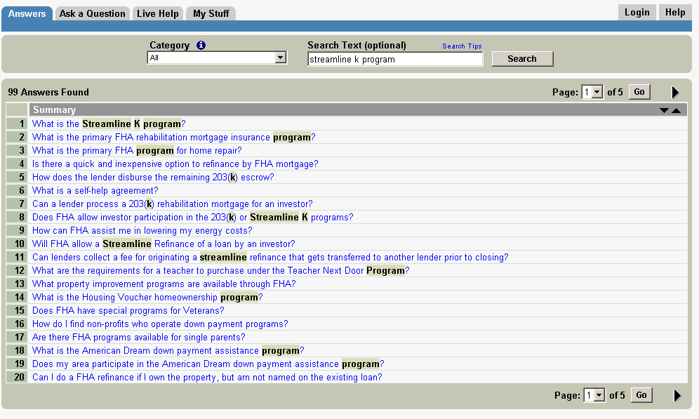
Activities:
- On the Answers tab, take a look at the “Category” pull-down select menu. Select “All” if it isn’t already. Next, type the keyword “Streamline K program”, and then click the search button.
- Select the “What is the Streamline K program?” answer.
- Provide feedback on how well this answer met your needs.
- To subscribe for an email notification when this article is updated, scroll down and click on “Notify me by email if this article is updated. The web site will prompt you to create an account as a consumer or lender, please create an account.
Discussion Points:
- When was this answer created?
- Are there any related answers for this search?
- What are the categories associated to the “What is the Streamline K Program?

Lesson 3: Ask a Question
Objective: Experience how customers “Ask a Question” to submit an incident.
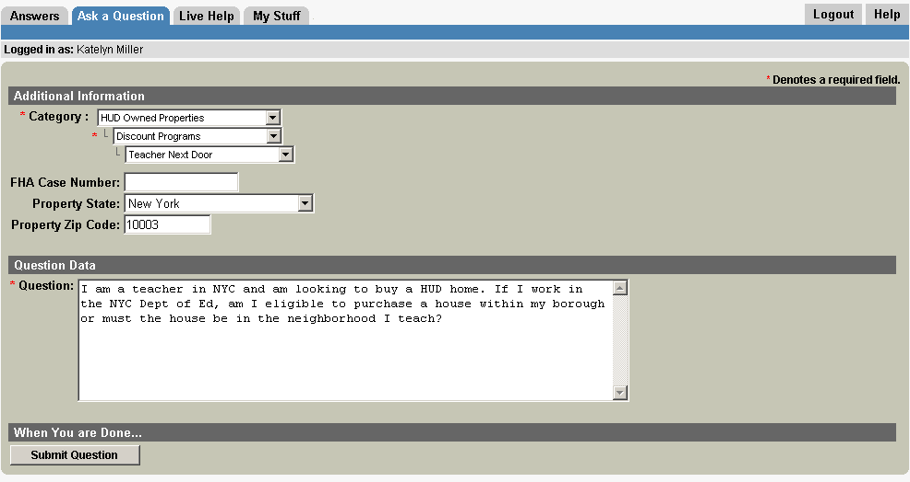
Activities:
- Select the “Ask a Question” tab.
- Since we are already logged in, we don’t need to enter our Email or create a new account. If you do not have a user account, you will need to create one from the My Stuff tab.
- In the Question field, enter :
I am a teacher in NYC and am looking to buy a HUD home. If I work in the NYC Dept of Ed, am I eligible to purchase a house within my borough or must the house be in the neighborhood I teach?”
- Select the appropriate category: HUD Owned Properties> Discount Programs > Teacher Next Door.
- Enter into the appropriate fields:
- FHA Case Number: (only for existing cases)
- State : New York
- Zip code = 10003.
- Click the “Submit Question" button.

- Consumer/Lender will receive a confirmation page once they select submit question as shown below:
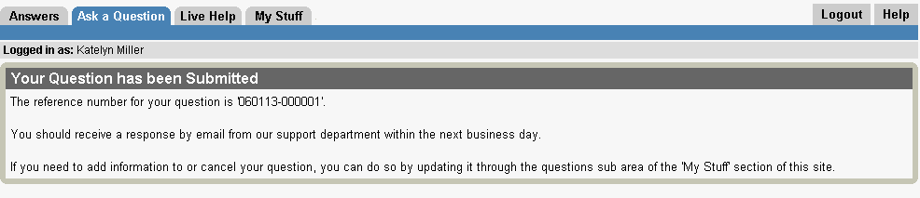

Discussion Points:
- What are the required fields on the Ask a Question Page?
- What are the first six digits of the Incident Reference Number?

Lesson 4: “My Stuff” Tab
Objective: My Stuff Tab provides customer access to messages from HUD personnel “Ask a Question” cases, provides Notification Management, and Account Profile information. Learn to use its features.

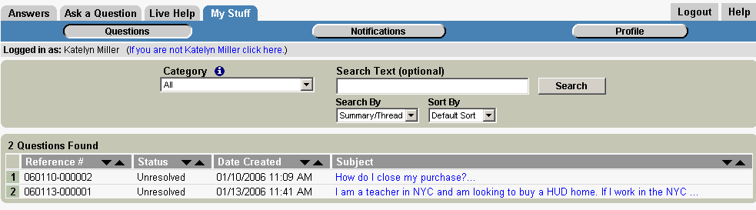
Activities:

- Select the My Stuff tab > Account Profile, and update username and password.
- Select Answer Update Notifications and delete the subscription you created in lesson 3, activity 4.Update your incident with additional information

Discussion Points:
- Will you receive a notification if your answer notification is about to expire? Why or why not?
- True or False: You can have multiple email addresses as a customer?
- True or False: If you have multiple email addresses as a customer, do all of your email addresses receive a copy of incident responses?
- Can a customer close his incident, or does an agent need to close it?

Appendix : Support Console Tab and Field Definitions:
Contact Tab: The Contact tab contains all the information about the contact associated with an incident, additional custom fields, and customer history.
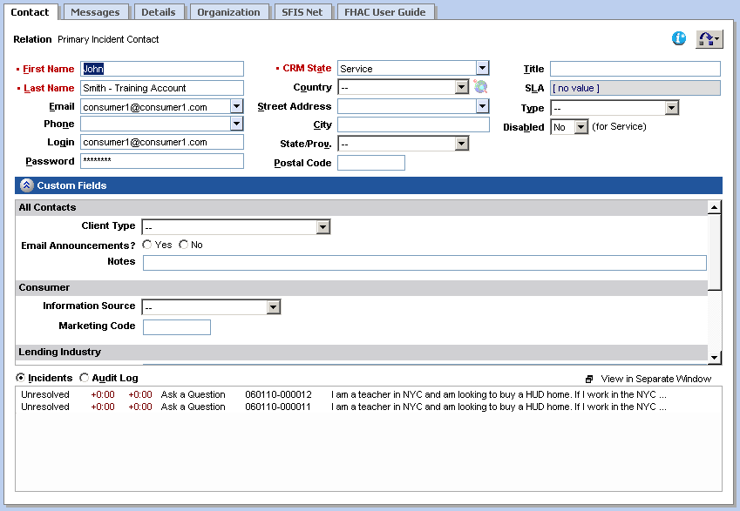
Contact Custom Fields:
All Contacts:
- Client Type
- Email Announcements
- Notes

Consumer
- Information Source
- Marketing Code

Lending Industry
- Organization
- Position
- Lender ID
- NAID
- TIN
- CHUMS ID

Message Tab: Discussion threads for incidents are located on the Messages tab. The straightforward format of the discussion thread enables you to quickly see all entries made to an incident; including the date and time each entry was made.
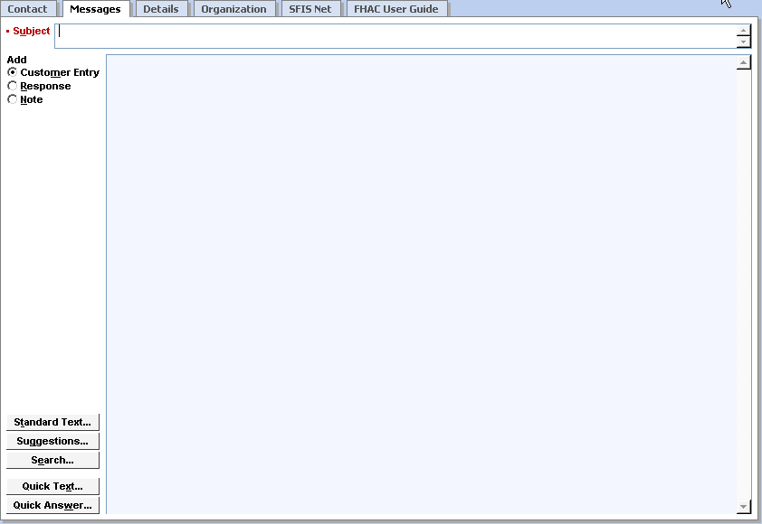
Subject: A brief summary of caller’s inquiry
Customer Entry: Enter customer inquiry for all phone calls, letters, and voicemails.
Response: Used to compose a response to the customer for all emails, Ask a Question, and fax incidents.
Standard Text: Predefined standard text used in incident.
Suggestions: System generated suggestions to answer customer inquiry.
Search: Search the knowledge base for applicable answers.
Quick Text: Shortcut to inserting standard text.
Quick Answer: Shortcut to inserting KB Answer.

Details Tab: The Details Tab contains all other incident details, including the mailbox and interface associated with the incident, the source of the incident, and any incident custom fields defined by your RightNow administrator. In addition, you can see any files that are permanently attached to the incident.
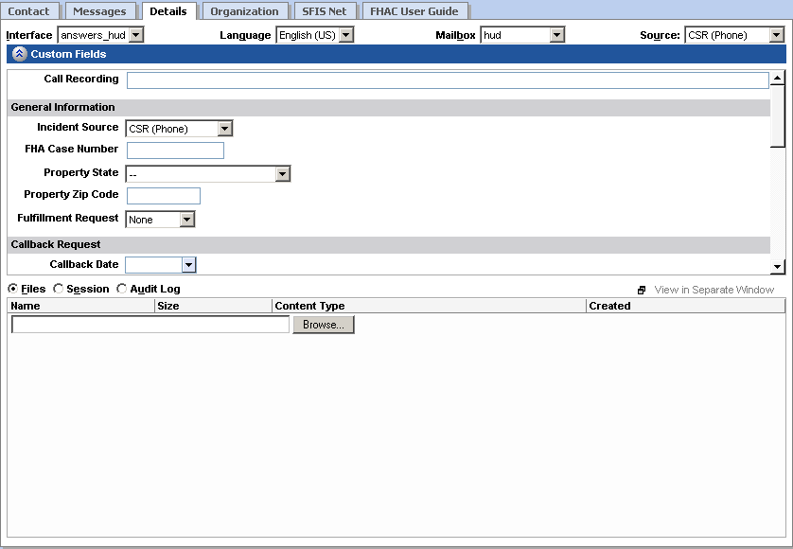
Incident Custom Fields:
Call Recording – For Quality Assurance Program Only
General Information
- Incident Source
- FHA Case Number
- Property State
- Property Zip Code
- Fulfillment Request

Callback Request:
- Callback Date
- Callback Time

Complaint
- Existing Request Number
- Complaint Against (Customer Type)
- Complaint Issue
- Complaint Level
- Single Family Complaint?
- Lender’s ID
- CHUMS ID
- NAID
- TIN

HUD Only – Correctly Escalated?
- HUD Staff
- GTM Verified
- Comments

Files: Add attachments via browse or view, download, delete, or access properties.
Session: View all actions performed by the end-user from your support site prior to submitting a question. Note: Only available from Ask A Question Incidents.
Audit Log: View the actions taken on the incident by the incident originator, agents, and the system.
Organization Tab: The Organization Tab contains all the information about the organization associated with the incident. As you can see John Smith does not belong to an organization.
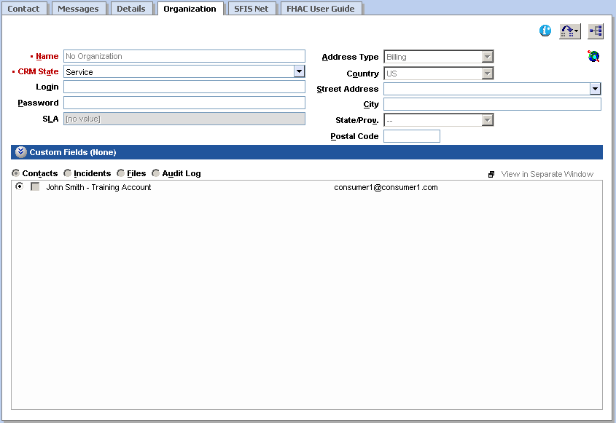
SFIS Net and FHAC User Guide Tabs are custom tabs available to access you in completing your incident.
Incident Side Panel – must be updated for each incident if there is a change.
Incident Reference Number: 12-digit number assigned to the selected incident.
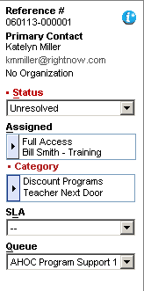
Primary Contact: primary contact information for consumer or lender.
Incident Status: Resolved, Unresolved, Updated, Waiting, and Referred:

Unresolved (unresolved) – New or Open Incidents.

Resolved (solved) – Incident has been solved.

Updated (unresolved) - Updated by Consumer/Lender via email or the My Stuff page.

Waiting (waiting) – Indicates waiting for consumer/Lender; depending upon configuration incidents in Waiting status may be set to Solved automatically by the system based on a specified period of time.

Referred (solved) - Incidents that are referred outside of the Resource Center and HOC – to NCS or another government agency.
Assigned: The assigned staff account.
Category: A mechanism for classifying incidents.
SLA: Service Level Agreement associated to organization or contact
Queue: A container for related incidents.
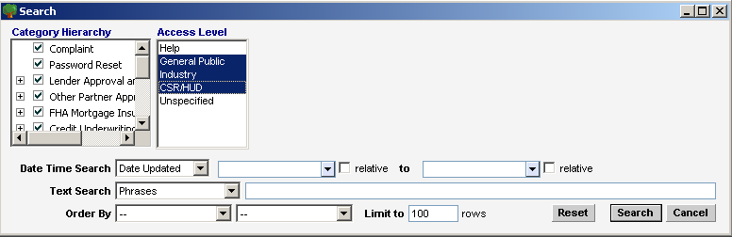

Answer Access Levels:
General Public: All customers will see answers assigned to the General Public Answer Access Level.
Industry: All Industry Customers will see answers assigned to the Industry Answer Access Level.
CSR/HUD: All KB Answers and Internal Answers that are not published on the End-User Pages.

