The ePerformance module within HR Connect is designed to be a very flexible, highly configurable application. Many variations of both the performance documents and the process for Performance Management are possible. This document gives what may be considered a default or standard process and explains some options for changing the process. This document contains images of three different performance documents to show some options for customizing documents to meet specific agency requirements.

This document focuses on the three roles that are primarily responsible for the Performance Management process for an individual employee – the employee (Employee), the employee’s manager (Rating Official), and the manager’s manager (Reviewing Official). There are other roles that participate in the Performance Management process – the Administrator, who helps set up the templates and maintains table-driven data, and the HR staff, who monitor the process and transfer documents as required. These support roles are not discussed in this document.

The Performance Management process is divided into three phases in this document. In the first phase, the employee and the rating official collaborate to create and establish a performance plan. This phase takes place at the beginning of the performance year. In the second phase, the rating official and the employee collaborate to maintain the performance plan, including a mid-year review if applicable. This phase takes place during the performance year. In the third phase, the rating official and the reviewing official collaborate to assign a final rating for the employee.

Phase 1 – Performance Plan Creation

Step 1 – Employee Creates Document

The employee logs into ePerformance.

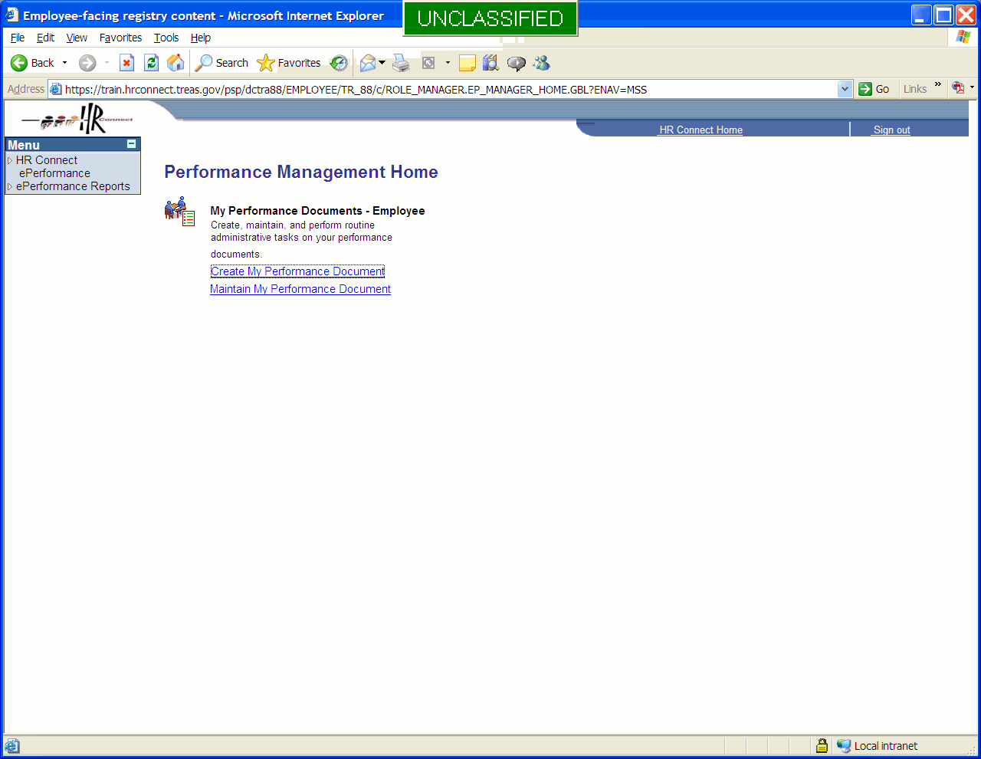

The employee selects the menu item Create Performance Document and specifies the correct template.

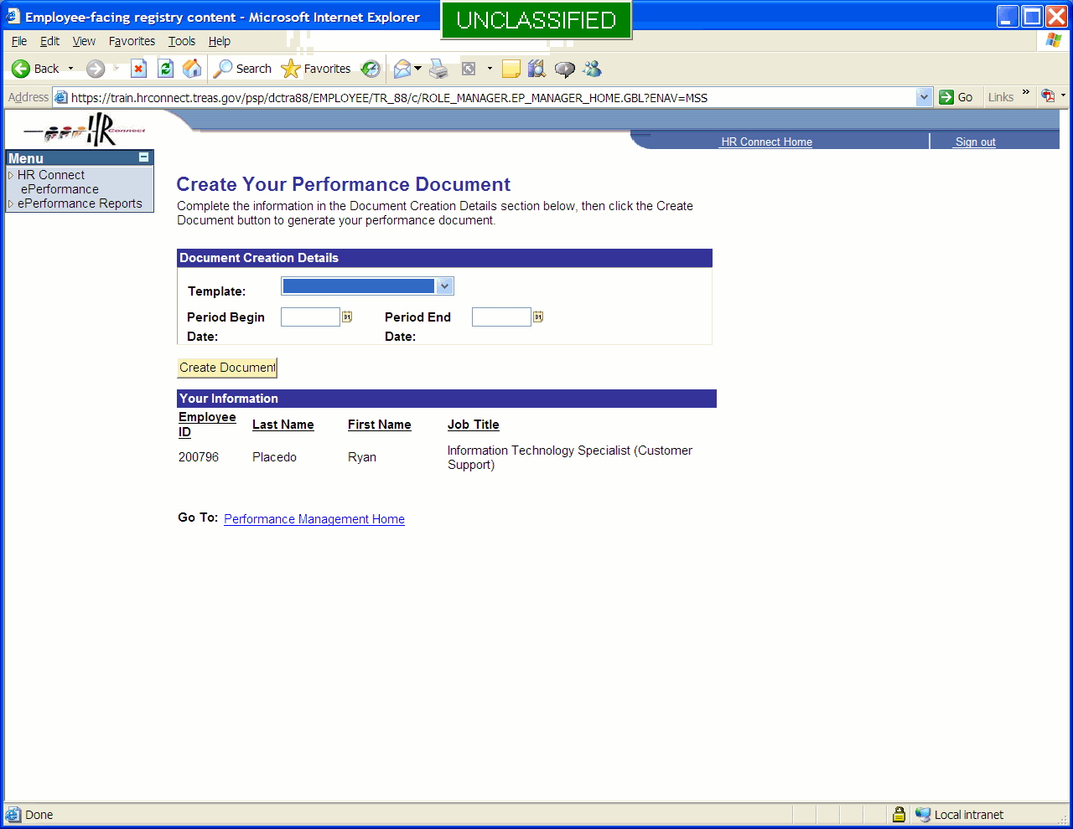

The Period Begin and Period End dates default in when the template is selected. These dates can be edited.

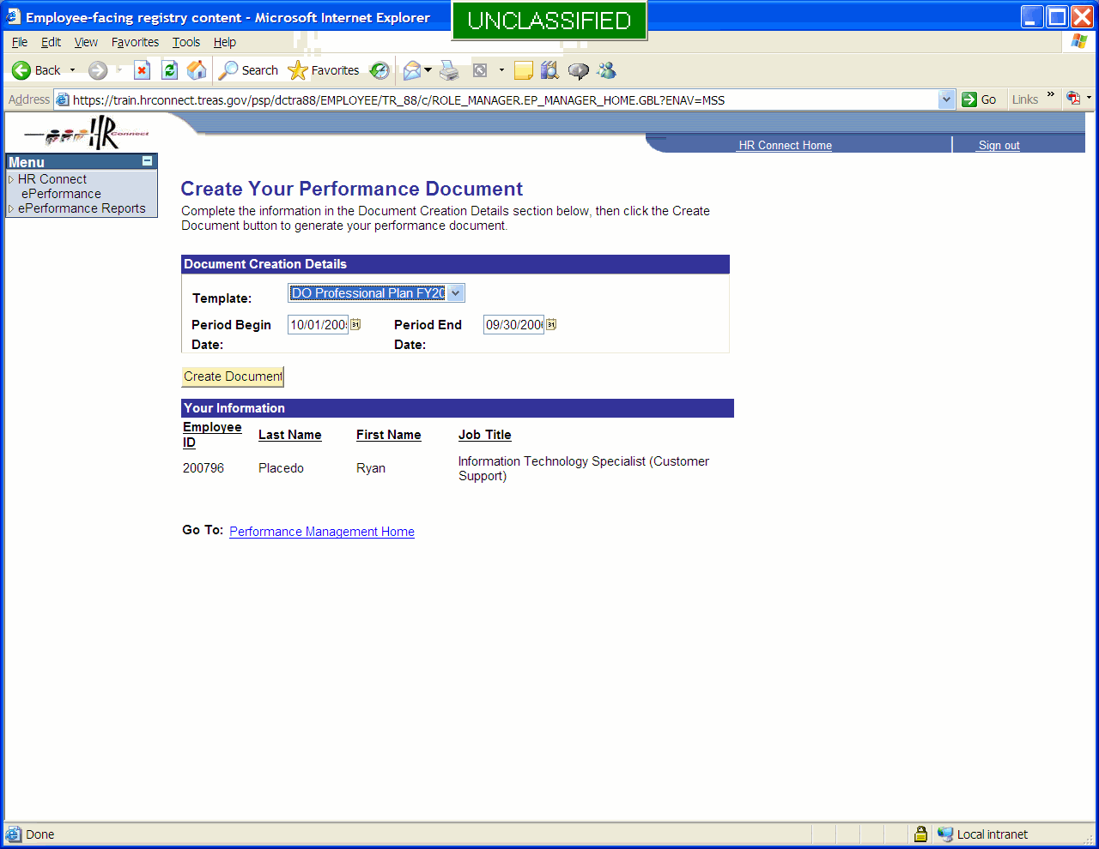

When the dates and template are correct, the employee selects the Create Document button. The document is created. The document status is ‘In Progress’. The employee completes any required information in the plan. This information will vary by employee group, and may include such items as a text description of goals and measures, performance elements selected from a list, or ties between performance elements and organizational goals or strategic plans.

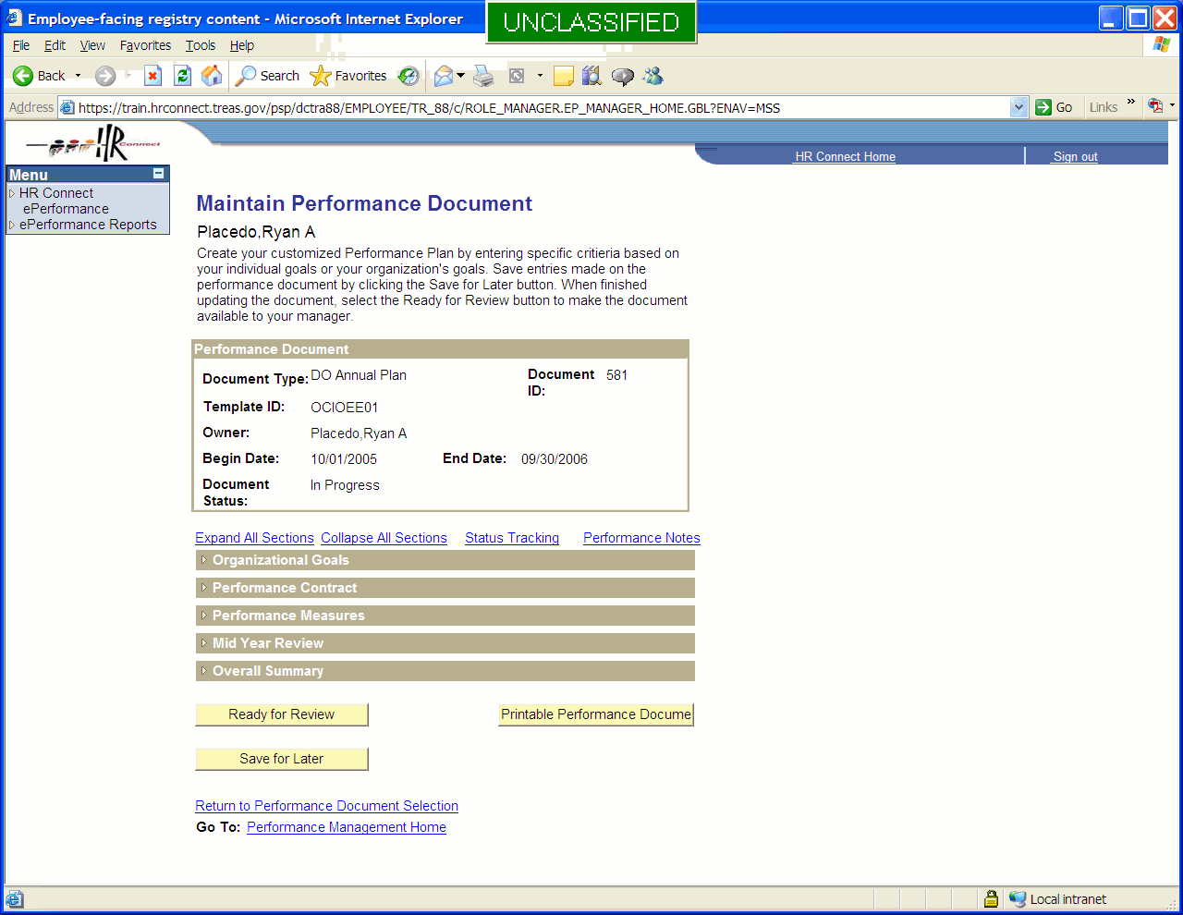

The next xx images show some of the possibilities for data entry

This is a text entry box for an Employee Contract. The text box can hold approximately 35,000 characters. There is a spell-check function, but the text box does not currently support the kinds of advanced formatting such as multiple colors, bold text, or bulleting that are included in word processing software such as MS Word.

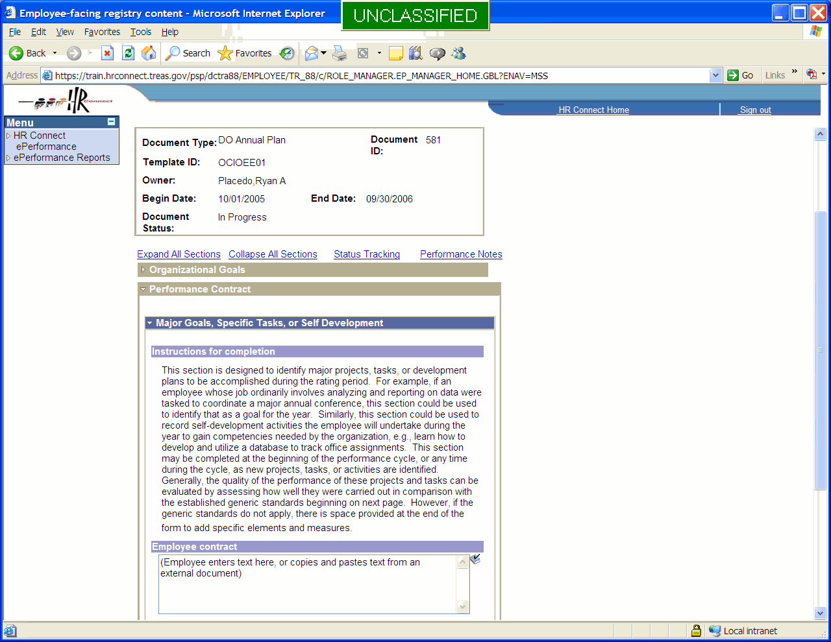

The text can be typed directly into the text box or copied from an existing document and pasted into the text box.

This is an example of data from drop-down lists. Note that the header information is different in this template – there is much more employee information. Note also that this template allows entry of performance plans for reasons other that the annual appraisal. In this case, plans can be entered for suppression or release of Within-Grade Increases, among other reasons.

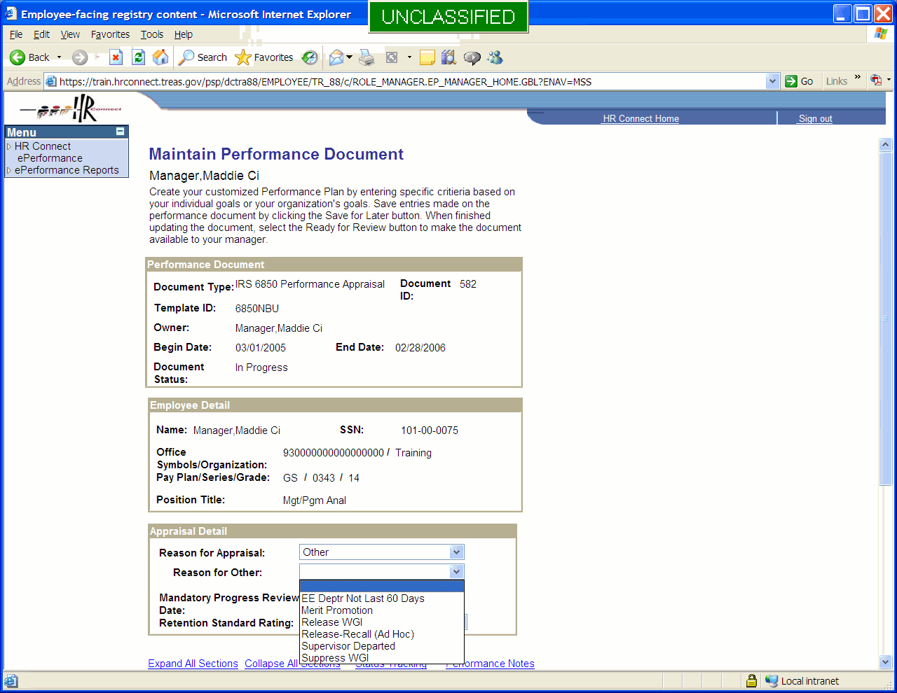

This is an example of selecting Critical Job Elements from a list.

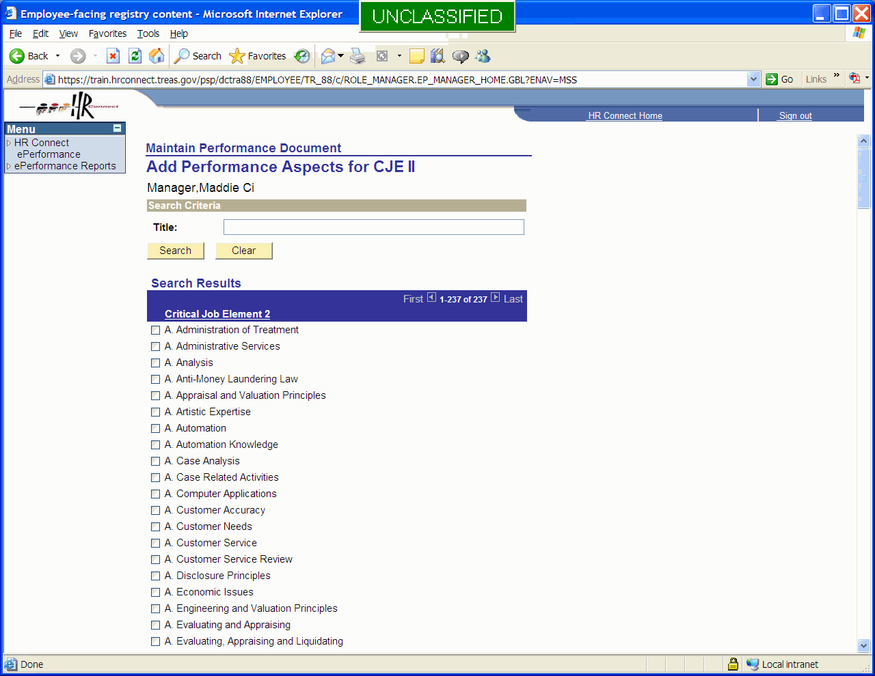

Once the employee has entered all required information, he or she forwards the document to the manager for review.

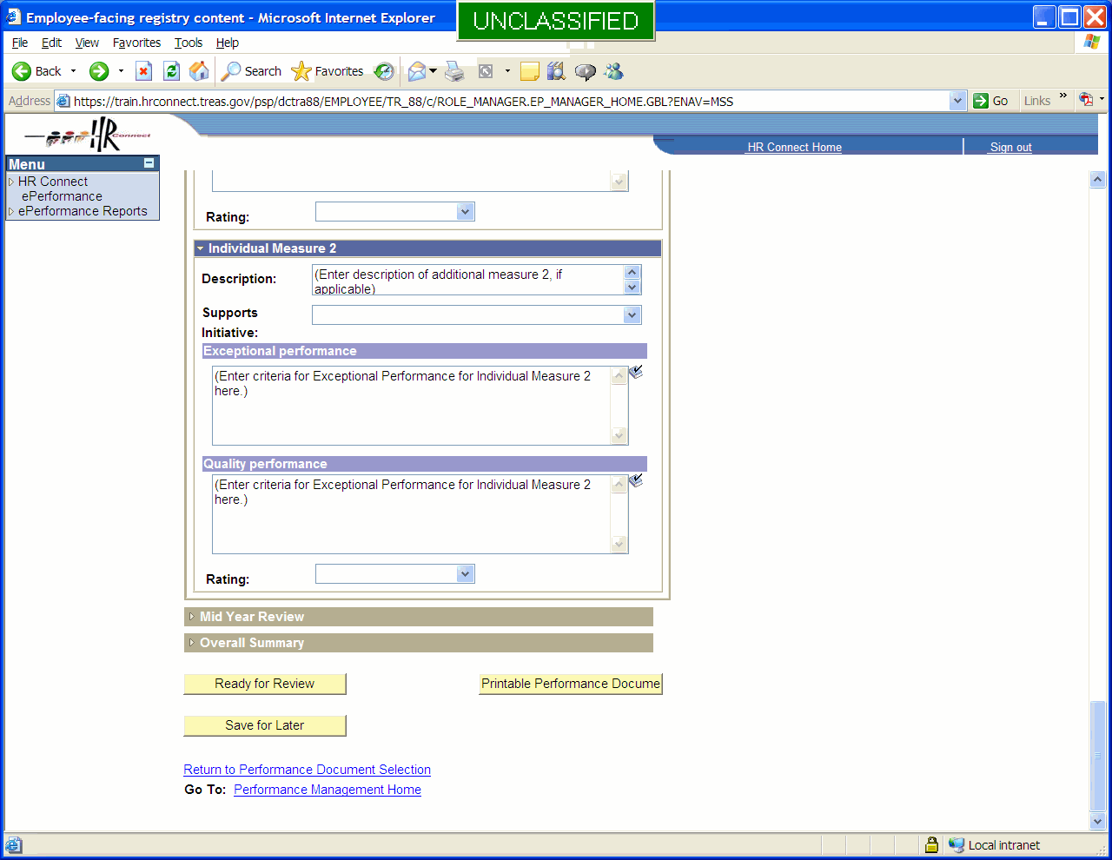

The document is in “In Progress” status when created. The “In Progress” status is very similar to having a document in draft form. In order to advance the document to the next status, the document must be forwarded to the manager for review by selecting the Ready For Review button. The employee may also save the document but not forward it, using the Save For Later button, or print the document.

Step 2 – The manager reviews and establishes the document

The manager logs into ePerformance.

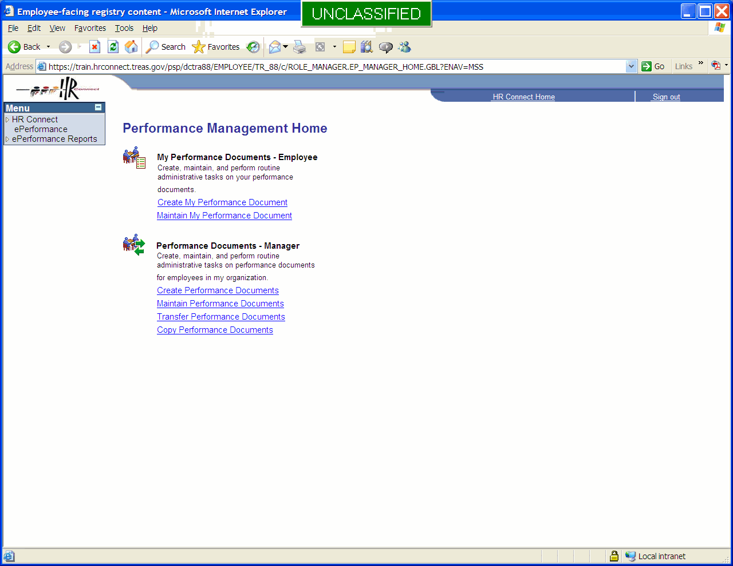

The manager page contains all features found on the employee’s page. In addition, the manager’s page contains features that allow the manager to manage and participate in the Performance Management process for his or her employees.

The manager selects plans created by employees and reviews them.

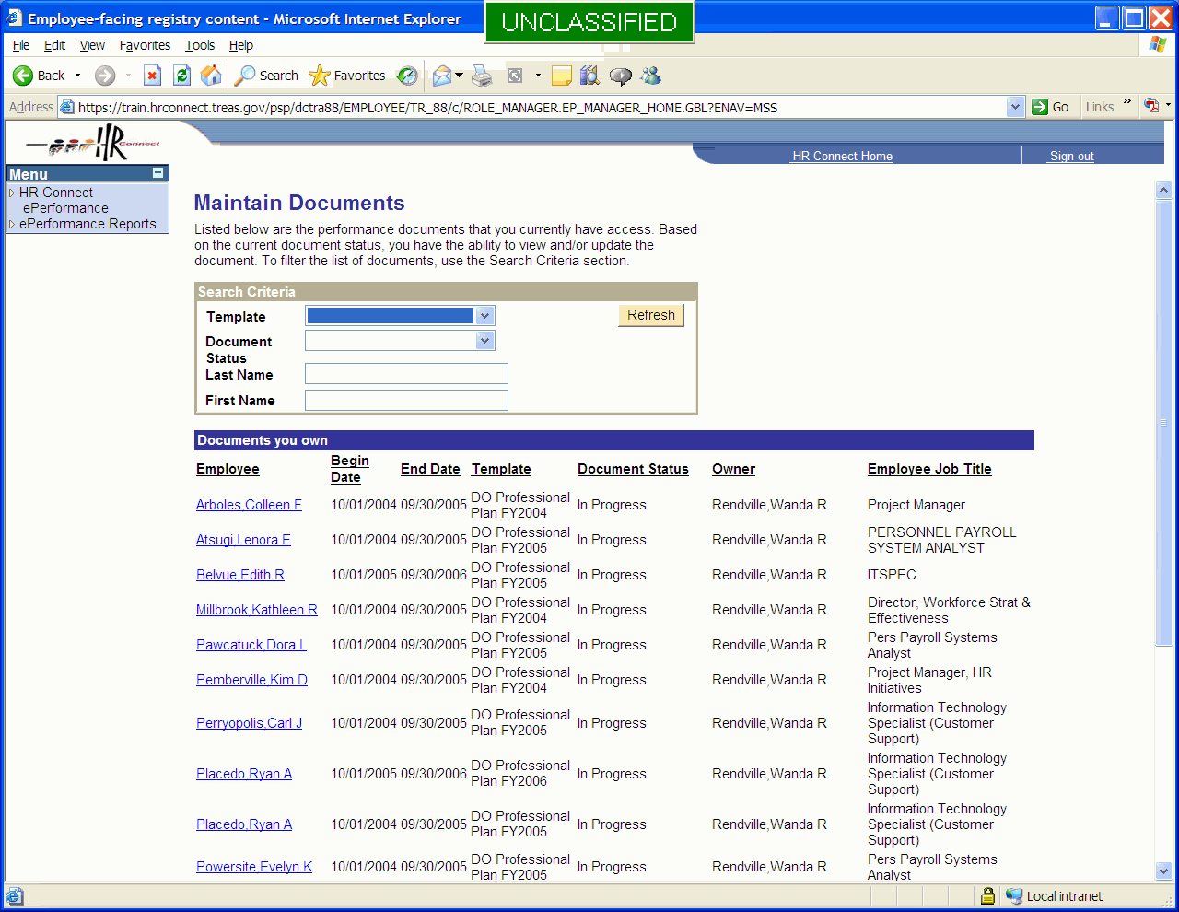

All the portions of the body of the document that were editable by the employee are editable by the manager. Note that the template and the Period Begin / Period End dates are not editable, either by the manager or by the employee. Documents that have incorrect dates or that are created with the wrong template must be deleted and a new document must be created.

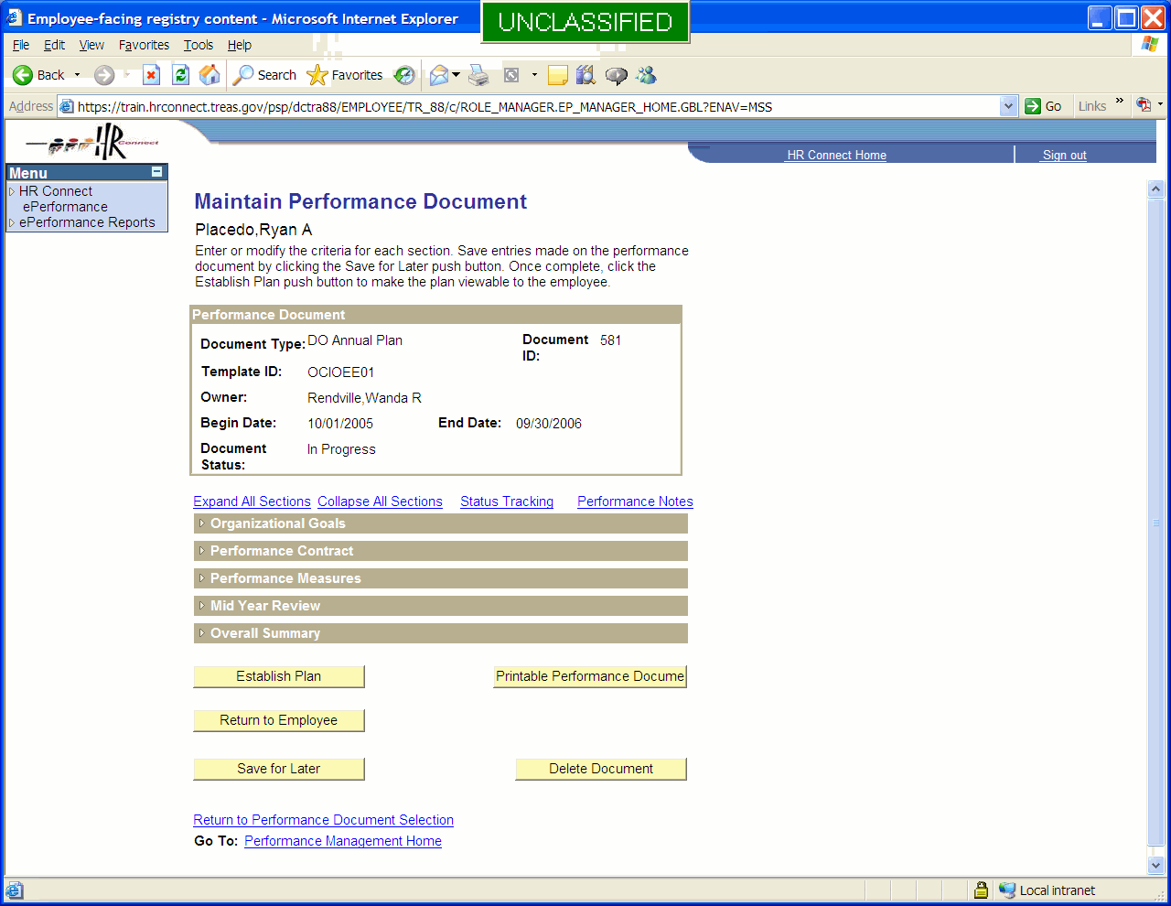

When the manager receives the plan from the employee, the document status is “In Progress”, or draft form. The manager reviews the data entered by the employee. The manager can edit the data, or return the document to the employee for revision by selecting the “Return to Employee” button. If no changes are required, or after changes have been completed, the manager can finalize the performance plan by selecting the Establish Plan button. This puts the plan into “Plan Established” status. The manager may also save the document but not finalize it, using the Save For Later button, or print the document. The manager also has the option to delete the plan.

Once the plan is established, the data entry fields become read-only, except for fields that are expected to be entered later, such as fields associated with the mid-year progress review.

This is the final step in the document creation phase. The document is ready to be used by the manager and employee.

Phase 2 – Manage Performance

Step 1 – Maintain the Performance Plan

The reviewing official signs in to ePerformance and selects the plan from the Maintain Performance Documents link in the Manager section.

When the document is in “Plan Established” status, the data entry fields are locked. If events during the performance year require a change to be made, the document must first be unlocked.

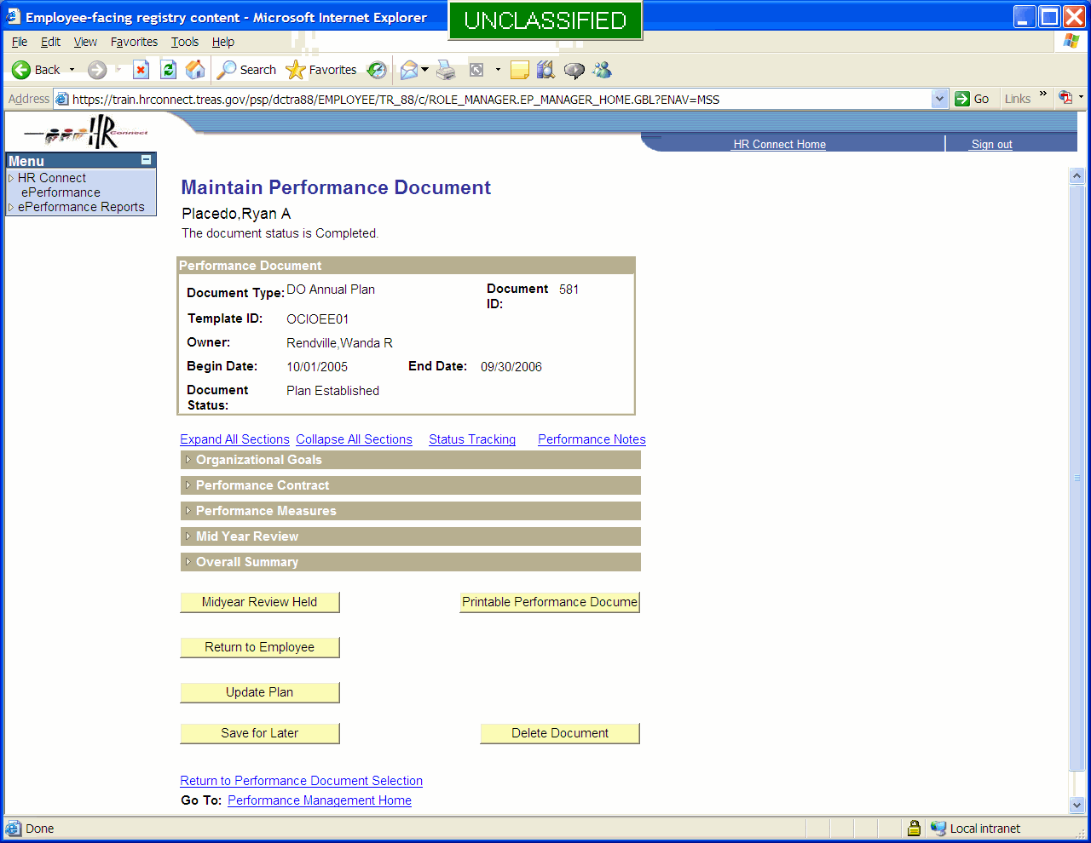

If the manager wishes to make the change, he or she unlocks the plan by selecting the Update Plan button. This places the plan back into “In Progress” status and makes the data entry fields editable. After making the changes, the manager can reestablish the plan. If the manager wishes to have the employee make the change, he or she selects the Return to Employee button. This places the plan back into “In Progress” status and makes the data entry fields editable. After making the changes, the employee selects the Ready For Review” button to send the document back to the manager. The document must be established again by the manager.

Step 2 – Midyear Progress Review

For plans that require a midyear progress review, the manager expands the section that contains the information about the progress review.

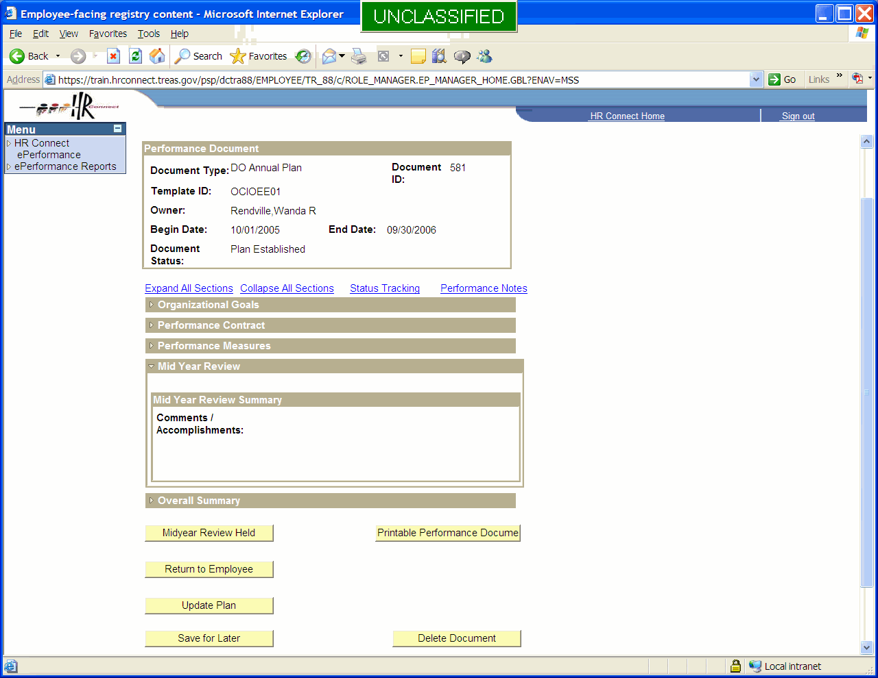

The plan above contains only a text box to record comments about the progress review. Additional information could be added, such as the date of the review.

The manager selects the Midyear Review Held button to change the plan status to “Midyear Review Held”.
When the plan reaches this status, the Mid Year Review text becomes editable. Also, the document can no longer be deleted. The document can still be updated or returned to the employee.

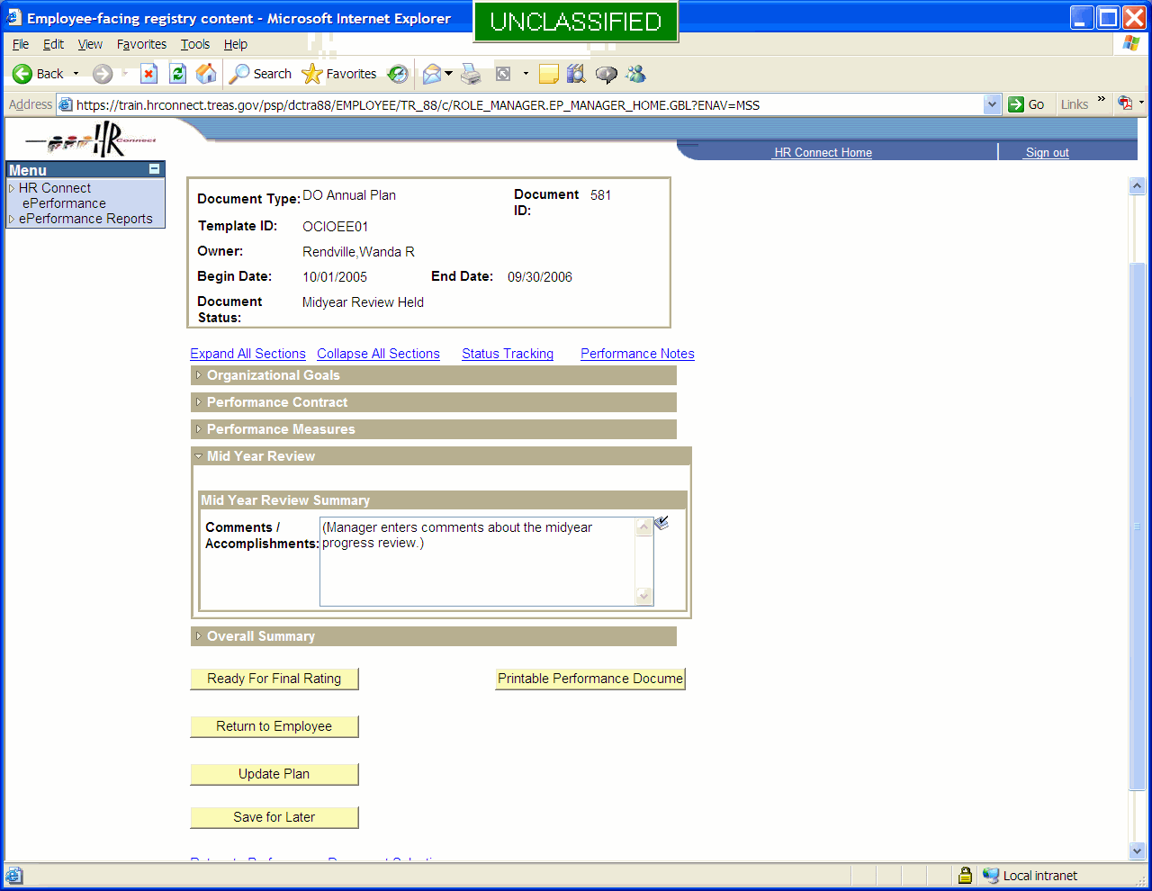

This is the final step in the manage performance phase. The document is ready to be rated when the end of the performance period is reached.

Phase 3 – Rating and Review

Step 1 – Lock Document For Rating

From the time the document is created and forwarded to the manager for review, the document is viewable to both the manager and the employee. At the end of the performance period, the manager first locks the document so that it is no longer visible to the employee. The document will remain locked from view of the employee until the rating and review process is complete. The manager locks the document by selecting the Ready For Final Rating button.

Step 2 – Assign Ratings

The manager opens the document and expands the sections that contain elements that will be rated.

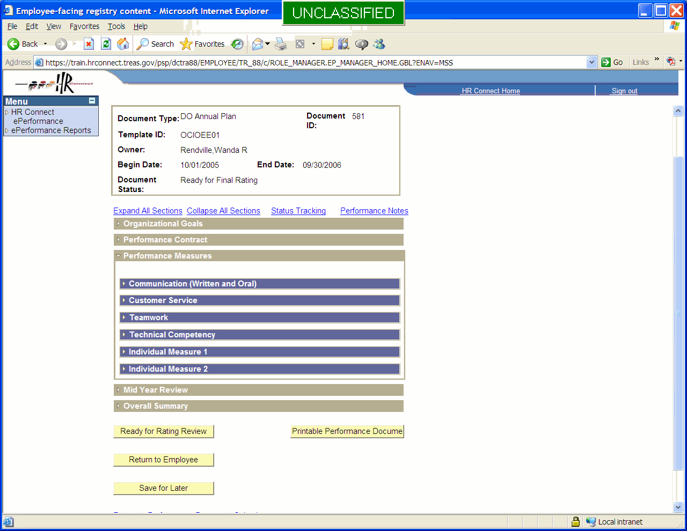

In the plan above, ratable elements are contained in the Performance Measures section. Plans can be designed to contain ratable elements in more than one section. Section labels can be customized.

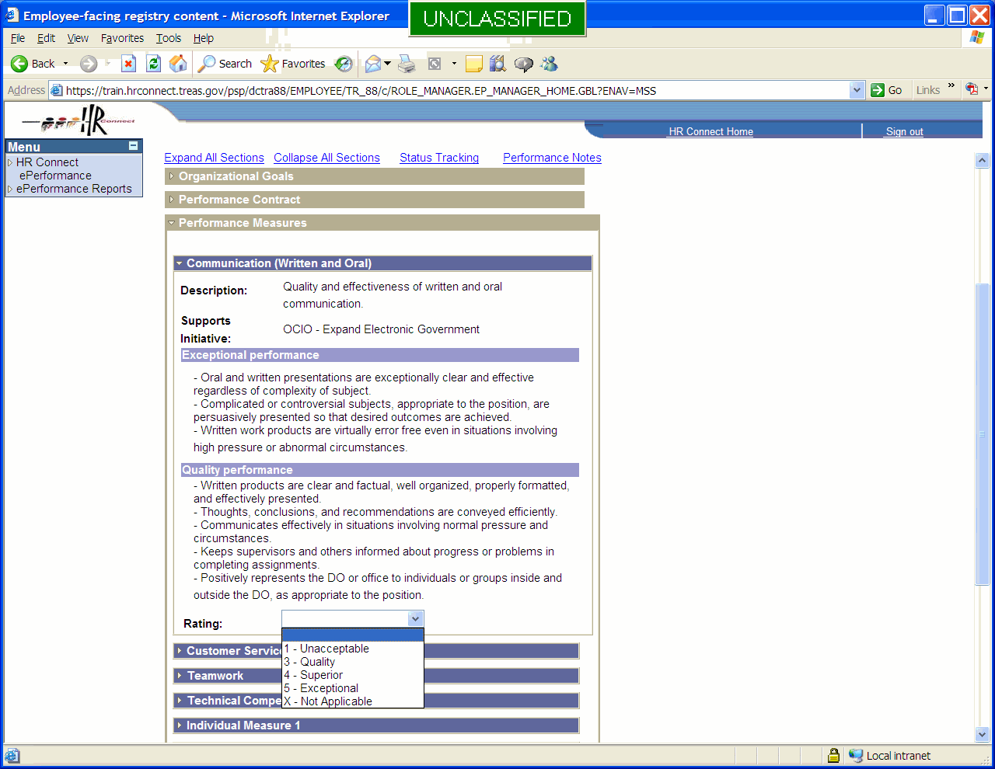

The manager rates each element using the scale specified.
After all ratable elements have been assigned a rating, the manager calculates the overall rating.

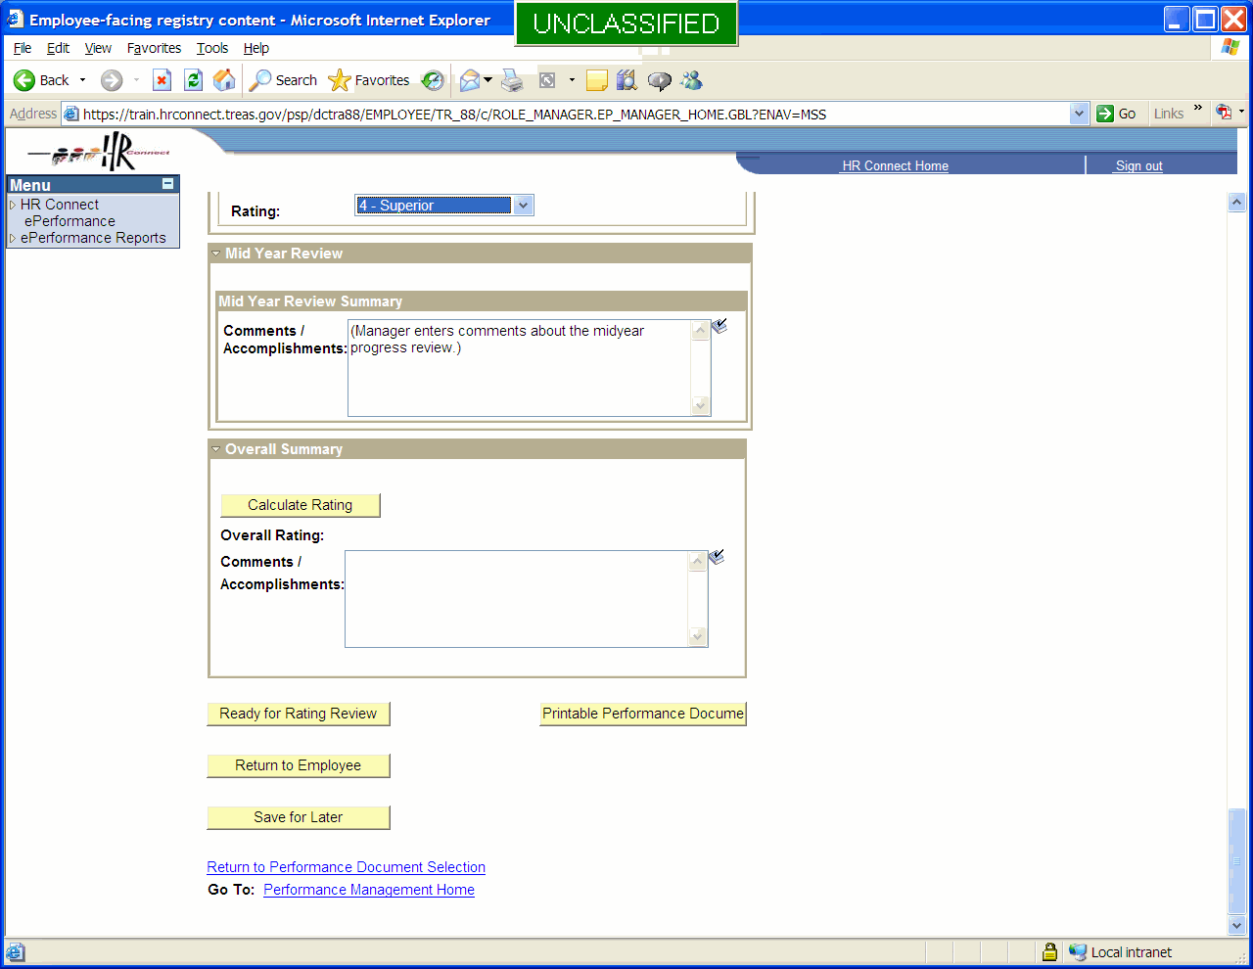

The application calculates the overall rating. The formula for this calculation, including any logic required to enforce calculation rules, is built into the template.

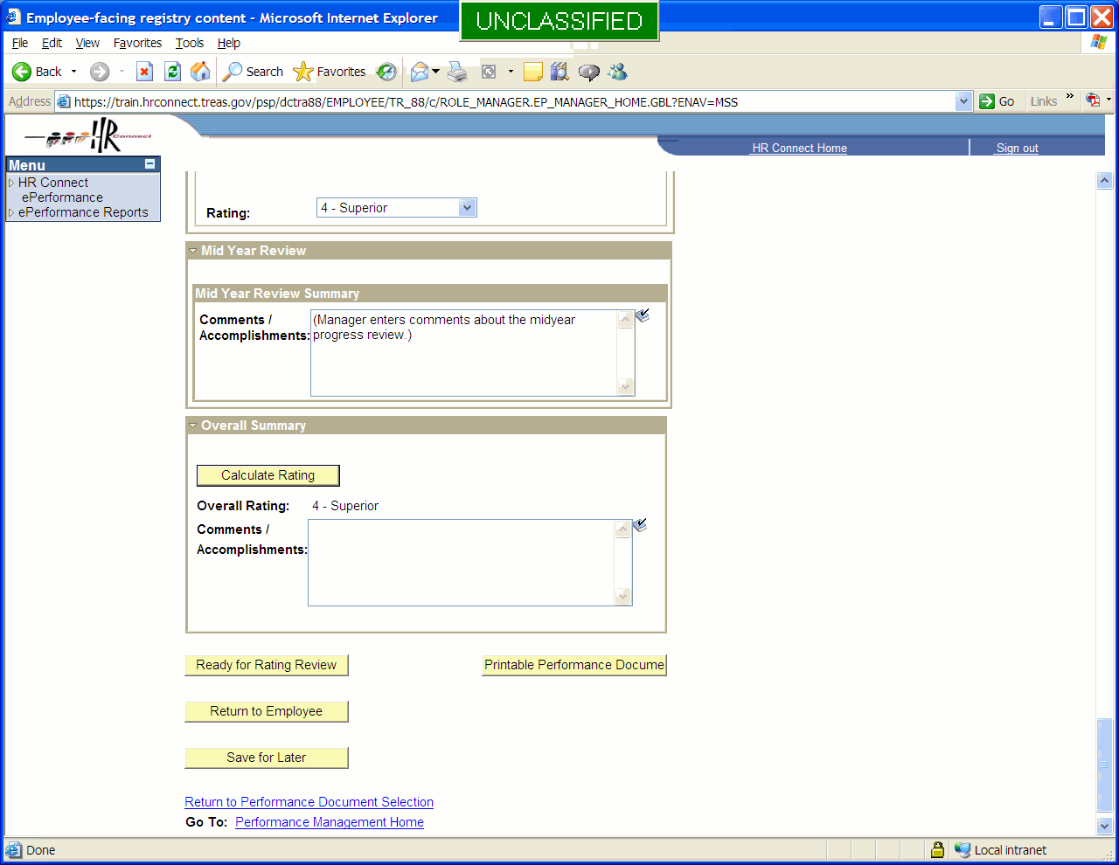

The manager also enters any comments in the text box in the Overall Summary Section.

When the plan has been rated and the overall rating has been calculated, the manager forwards the plan to the reviewing official by selecting the Ready For Rating Review button.

Step 3 – Rating Review

The reviewing official signs in to ePerformance and selects the plan from the Maintain Performance Documents link in the Manager section.

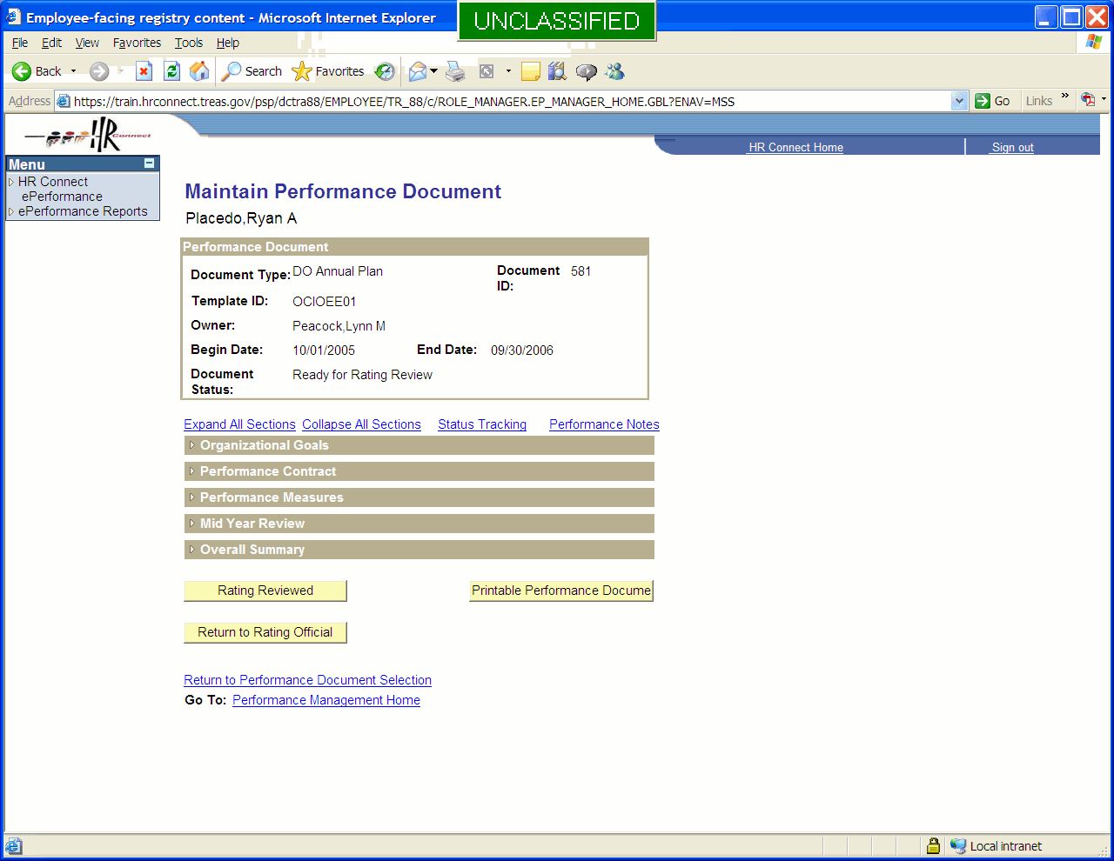

All fields in the plan are read-only for the reviewing official. The reviewing official cannot make changes to the document. If changes are required, the reviewing official selects the Return To Rating Official button, and the document is returned to the rating official in editable form. The rating official makes changes and returns the document for review. If no changes are required, the reviewing official selects the Rating Reviewed button. Selecting this button does three things. First, it sends the rating and other appraisal information to the HR Connect Administer Workforce Manage Performance page, setting the interface flag so that the rating will be sent to NFC in the next interface run. Second, it returns ownership of the document to the rating official in read-only form. Third, it unlocks the document so that the employee can once again view it.

This is the end of the Rate and Review phase. Other actions are possible: the employee or manager can copy the document forward to create the plan for the next performance year, and the manager can rework the document to correct an error or to reflect the results of a LR / ER action.

