Employee Self Service (ESS) – Employee SF-50 Notifications.

Functionality has been added to ESS – My Information to allow employees to access their SF-50 notifications.

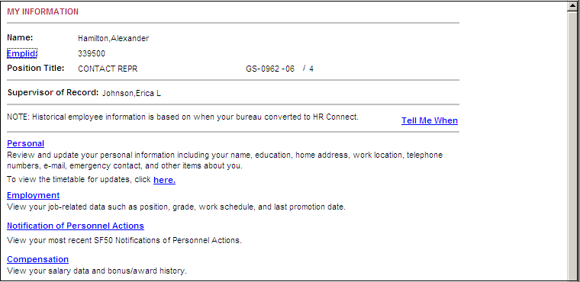

When the Notification of Personnel Actions link is pressed, the My Information – SF-50 Notification of Personnel Action page is displayed as shown on the next page.

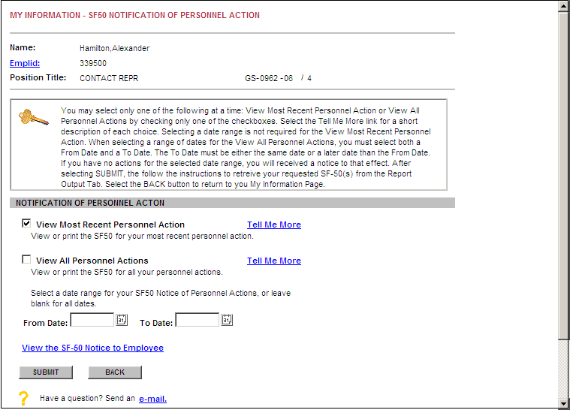

An employee may: View the SF-50 for his most recent personnel action, view the SF-50s for all his personnel actions or view a date range of SF-50 notifications.

SF-50 Notifications from January 2007 to the present are loaded in HR Connect.

The “Tell Me More” links on the page provide explanations for each option. The “View the SF-50 Notice to Employee” link allows the employee to view or print the Notice To Employee information printed on the back of Employee Copy of the SF-50.

Normal HR Connect error messages are included on the page, For example, the following message would be displayed if the employee un-check both View/Print options.

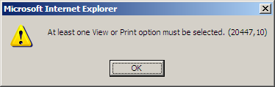

If the employee selects only one date in the date range or selects an invalid date range (From Date > To Date), a message like the one below will be displayed.

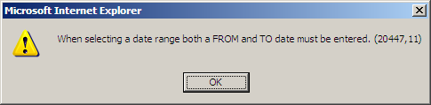

When the SUBMIT Button is selected, the SF-50’s will be generated outputted to the HR Connect - Report Output page.

