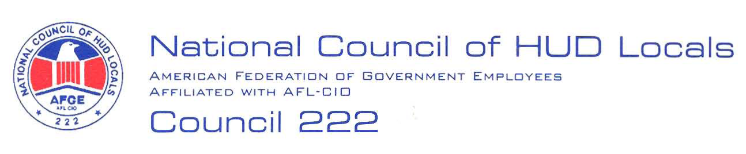

March 14, 2007

MEMORANDUM FOR: Priscilla Lewis, Acting Deputy Director, Labor and
Employee Relations Division, ARHL

FROM: Lisa A. Lowery, Co-Chair, Mid-term Bargaining Team,
AFGE Council 222

SUBJECT: Pilot Program – Service Level Agreement for Centralized Business
Service Functions between the Office of Administration and the
Office of Community Planning and Development

This serves as AFGE Council of HUD Locals 222 demand to bargain over the proposed subject pilot program. Our preliminary proposals are as follows:

- Relocation, Separation and Downgrade: No employee will be involuntarily relocated, separated or downgraded as a result of this pilot.
- Local Bargaining: In accordance with Article 5, bargaining will be conducted at the local level concerning local issues for example: space moves. All previously issued notices regarding space moves are null and void. No notices regarding moves will be issued until Council bargaining is completed.
- Removal from the Bargaining Unit – No employee will be removed from the bargaining unit as a result of this pilot program.
- Details: Details will be accomplished in accordance with Articles 13 and 14 of the HUD/AFGE Agreement.
- Copies of Supplements: All members of this negotiation team with a copy of this signed supplement within 30 days.
- Positions and Promotions: There will be no adverse impact on employees’ upward mobility or career ladder positions or promotions. This is to include any accretion of duties promotions. Grade controlling duties will not be removed.

2.

- Telecommuting: All employees affected by this reorganization will be allowed to telecommute under the Department’s telework policies including telecommuting up to three days per week and no telecommuting arrangements presently in place will be curtailed.
- Reasonable Accommodations: Any Reasonable Accommodation request that has been previously approved will remain in force including but not limited to work at home.
- No Change in Duties: No employees will have a change in any position responsibilities.

These are preliminary proposals only, and the union reserves the right to bargain or amend or add proposals, in accordance with Article 5. Council President, Carolyn Federoff, has been named Chief Negotiator for these negotiations.



