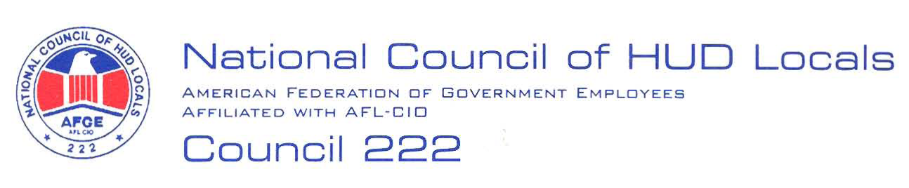

July 6, 2007

MEMORANDUM FOR: Priscilla A. Lewis, Chief, Labor Relations Branch, ARHLL

FROM: Sherry Norton, Co-Chair, Midterm Bargaining Team, AFGE Council
Of HUD Locals 222

SUBJECT: FHEO Section 3

This will serve as AFGE Council of HUD Locals 222 demand to bargain over the proposed movement of the FHEO Section 3 responsibility from Headquarters to the Field. Below are our preliminary proposals:

- Classified Position Descriptions: A position description shall be developed that includes the responsibilities of Section 3 and it must be classified before any employee is assigned Section 3 responsibilities.

- Copies of Position Descriptions: The Union shall be provided a copy of the classified position description within 30 days of classification.

- Adjustment of Workload: All employees assigned the responsibilities of Section 3 shall be given a workload adjustment to accommodate this new assignment.

- Adjustment of Performance Rating: There shall be no adverse impact to the performance ratings of all employees assigned the responsibilities of Section 3.

- Local Bargaining: The Local Union shall receive notifications in accordance with Article 5 of the HUD/AFGE Agreement regarding local changes that may occur to bargaining unit employees including but not limited to moves, details and reassignments.

- Teleworking: There shall be no adverse impact to the telework agreements of the affected employees.

- Reasonable Accommodations: There shall be no adverse impact to any reasonable accommodation of any affected employee.

- Work at Home: There shall be no adverse impact to any work at home agreement of any affected employee.

- Annual Leave: Any annual leave previously approved shall not be rescinded as a result of this shift of responsibilities.

These are preliminary proposals only, and the union reserves the right to bargain or amend or add proposals, in accordance with Article 5. Carolyn Federoff or I will notify you when the Executive Board has selected a Chief Negotiator.

