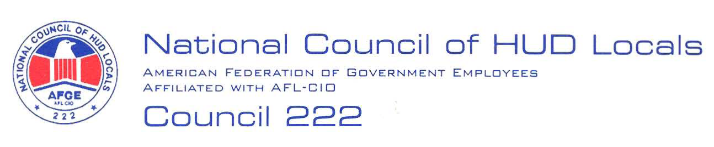

March 7, 2007

MEMORANDUM FOR: Deborah Swann, Acting Chief, Labor Relations Branch,
ARHLL

FROM: Lisa A. Lowery, Co-Chair Mid-Term Bargaining Team,
AFGE Council of HUD Locals #222

SUBJECT: Field Policy and Management – Operating Protocols

I have received notification under Article 5, Section 5.02 of the HUD/AFGE Agreement of management’s interest regarding Field Policy and Management’s proposed intent to implement five (5) new operating protocols.

This memorandum will serve as AFGE Council #222’s demand to bargain regarding the proposed Field Policy and Management - Operating Protocol changes. Management must maintain the status quo until bargaining has been completed. Below are the Council’s preliminary proposals. These are preliminary proposals only and the Union reserves the right to bargain or amend or add proposals in accordance with Article 5 or request additional information

We recognize, however, that bargaining to amend a contract during its term is permissive. That is, either party can propose to bargain; either party can insist on maintaining the current conditions without bargaining; and either party can engage in bargaining without prejudice to its right to later cease bargaining and insist on maintaining the current conditions. Of the five proposed changes to FPM Protocols, number I. Discipline of outstationed employees is covered by the current contract. Although our preliminary proposal necessarily must be the retention of the current policy, in regards to change number I, if we were to engage in permissive bargaining, possible proposals might be included in future union proposals.

Our current contract specifically allows field employees third level of grievance review to be the Regional Director (RD) or the Field Office Director (FOD), past Title language for those positions. See Article 22.12 Page 116 under step three. There is no alternative step three deciding official created in these proposed changes and the due process rights of employees in the field would be unjustifiably harmed with this proposed change, without a step three deciding official for a grievance. Meaning we can’t have the proposing and the third level deciding official be the same person.

The following preliminary proposals are submitted:

- Proposing/Deciding Officials: All field employees will maintain a third level grievance officer of either the RD or FOD.
- Rating Officials: An employee’s rating official will be within the program area chain.

2.

- EPPES Ratings: Employees may be rated on any work assignment to meet any work plan or departmental goal. Any RD/FOD work assignments will not adversely impact employee’s program area performance reviews but may supplement their performance evaluation by noting extra work assignments for the office.
- Awards: Employees assigned work outside of their program work areas shall be eligible for recognition through the HUD awards process.
- Single Management Point of Contact: HUD agrees that employees will not be required to report to multiple supervisors regarding work assignments. A single point of contact (POC) for employees reporting to management on work assignments when RD’s or FOD’s assign work will remain with the program Supervisor.
- Supplement Retention: All current Supplements that deal with RD or FOD participation with assignment of work of supervisory oversight, including Supplement 39 will remain unchanged.
- Work Assignments: Work assignments made by RD’s or FOD’s shall take into consideration the grade, job title and position of the employee. No employee shall be required to perform a function they are clearly not trained or qualified for.
- Work Plan: All work assignments shall be reflected in an employee’s work plan and communicated to the employee by the program Supervisor before performance of any assignment is expected.
- Prioritization of Work Assignment: Program Supervisors shall provide employee’s with a prioritization of work assignments if an employee has been requested to perform functions for the RD’s or FOD’s.
- Training: Employees may receive training for job assignments made by the RD’s or FOD’s.

These proposals are initial proposals and are not to be considered the limit of the union’s proposals in response to management’s notification of changes about this subject.

By attempting to respond in a positive fashion to management’s notification of proposed changes the Union is not waiving any rights to bargain or to insist on maintenance of the status quo without bargaining.

Thank you for the notification and opportunity to provide a response to your proposed changes. President Federoff or I will notify you regarding the Chief Negotiator upon the approval of the Executive Board.

cc: Council President Carolyn Federoff
Council #222 National Bargaining Team



