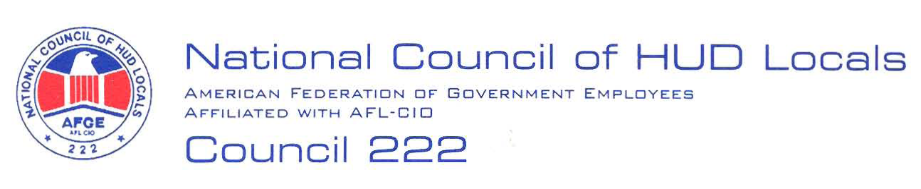

August 20, 2008

MEMORANDUM FOR: Norman Mesewicz, Deputy Director, Labor Employee
Relations Division, ARHL

FROM: Lisa A. Lowery, Chair, Midterm Bargaining Team, AFGE Council
Of HUD Locals 222

SUBJECT: Activities of the fourth quarter streamlined hiring initiative
545 external positions

This will serve as AFGE Council of HUD Locals 222 demand to bargain the
proposed subject Management initiative. Below is our preliminary proposal:
No Adverse Impact: The subject Management initiative shall have no adverse impact on any bargaining unit employee.
This is a preliminary proposal only, and the union reserves the right to bargain or amend or add proposals, in accordance with Article 5. Russell Varnardo, President, or I will notify you of the selection of the Chief Negotiator.

