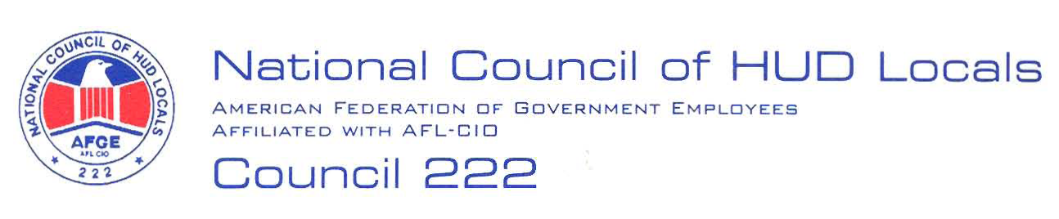

February 14, 2008

MEMORANDUM FOR: Norman Mesewicz, Deputy Director, Labor Employee
Relations Division, ARHL

FROM: Lisa A. Lowery, Co-Chair, Midterm Bargaining Team, AFGE Council
Of HUD Locals 222

SUBJECT: HSPD-12 – New Federal ID Credential

This will serve as AFGE Council of HUD Locals 222 demand to bargain over the proposed replacement procedures for the New Federal ID Credential. Below are our preliminary proposals and information request:

- Written Procedures: No less than annually, all employees will receive a copy of the written procedures to replace the New Federal ID Credential.
- Changes in Procedures: Any changes made to the procedures provided in the Article 5 Notice dated February 4, 2008, must be negotiated with the Union before implementation.
- Continued access: Employees will not be denied access to a federal building and/or Departmental space due to not having the New Federal ID Credential.
- Employee Certification: In the absence of a police report, employees may provide a written statement certifying that the New Federal ID Credential was stolen.

Additional information is needed before negotiations:

- A copy of the contract regarding the New Federal ID Credential.
- Provide information as to what is included in the 3 years maintenance.
- Provide information as to what is included in the professional service to support the New Federal ID Credential.

These are preliminary proposals only, and the union reserves the right to bargain or amend or add proposals, in accordance with Article 5. Russell Varnardo has been selected as Chief Negotiator.

