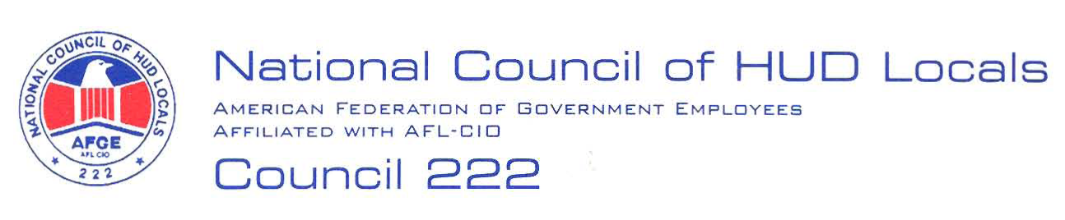

February 20, 2008

MEMORANDUM FOR: Norman Mesewicz, Deputy Director,
Labor and Employee Relations Division, ARHL

FROM: Lisa A. Lowery, Co-Chair, Midterm Bargaining Team, AFGE Council
Of HUD Locals 222

SUBJECT: Supervisory Changes in Office of Public and Indian Housing

This will serve as AFGE Council of HUD Locals 222 demand to bargain over the proposed supervisory changes in the Office of Public and Indian Housing. Below are our preliminary proposals:

- Relocation, Separation, Downgrade: No bargaining unit employee shall be involuntarily relocation, separated or downgraded as a result of this change.

- Promotions/Upward Mobility: There shall be no adverse impact on any employees’ promotions, upward mobility, or career ladder positions as a result of this realignment.

- Local Bargaining: The Local Union shall receive notifications in accordance with Article 5 of the HUD/AFGE Agreement regarding local changes that may occur to bargaining unit employees including but not limited to moves, details and reassignments.

- Teleworking: There shall be no adverse impact to the telework agreements of the affected employees.

2.

- Reasonable Accommodations: There shall be no adverse impact to any reasonable accommodation of any affected employee.

- Work at Home: There shall be no adverse impact to any work at home agreement of any affected employee.

- Annual Leave: Any annual leave previously approved shall not be rescinded as a result of this realignment.

- Bargaining Unit Status: No employee shall be removed from the bargaining unit as a result of this reorganization.
These are preliminary proposals only, and the union reserves the right to bargain or amend or add proposals, in accordance with Article 5. President Federoff or I will notify you when a Chief Negotiator has been selected by the Executive Board.

