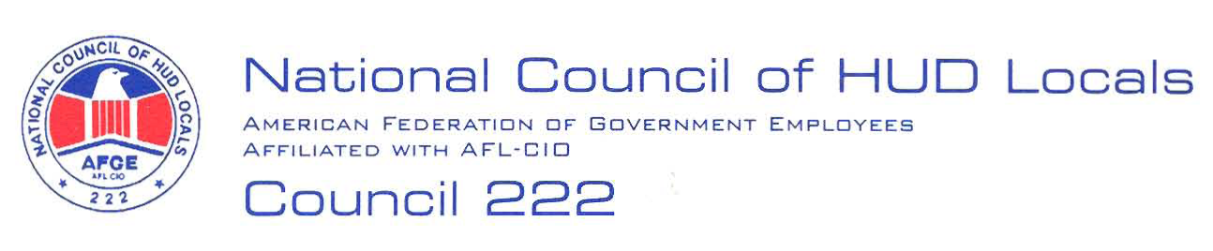

May 13, 2008

MEMORANDUM FOR: Norman Mesewicz, Deputy Director, Labor Employee
Relations Division, ARHL

FROM: Perry Casper, EVP and Midterm Bargaining Team member, AFGE Council
Of HUD Locals 222

SUBJECT: Microsoft update and Information Technology Modernization Initiative

This will serve as AFGE Council of HUD Locals 222 demand to bargain over the changes to the HUD Technology Modernization Updates. Below are our preliminary proposals:

- Changes in Procedures: Any changes made to the procedures provided in the Article 5 Notice must be negotiated with the Union before implementation.
- Continued access: Employees will not be denied access to modernization updates to meet program work, unless the process has been negotiated under the new Technology update changes.
- Necessary Training Requirements: HUD will provide all employees the necessary training to operate any new programs prior to their required use.
- Continued Enforcement: HUD agrees that no Contract /Supplement changes will take place unless specifically included in negotiations.

These are preliminary proposals only, and the union reserves the right to bargain or amend or add proposals, in accordance with Article 5. Gary Mongelli has been selected as Chief Negotiator and can be reached at (303) 672-5240.

