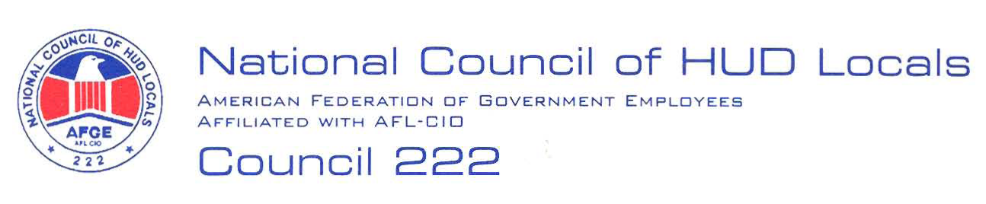

October 19, 2007

MEMORANDUM FOR: Priscilla A. Lewis, Acting Deputy Director, Labor and
Employees Relations Division

FROM: Videssa Woods, Co-Chair, Midterm Bargaining Team, AFGE Council
Of HUD Locals 222

SUBJECT: Service Level Agreements (SLA) for Office of Administration Centralized Business
Service Functions

This is AFGE Council of HUD Locals 222’s demand to bargain regarding the proposed SLAs. Preliminary proposals are as follows:

- Overview: All employees shall be given an overview of the SLA.

- Obligation for Bargaining: Parties agree that the proposed implementation of a SLA for each program office requires Article 5 notification and negotiations.

- Training: All managers and supervisors shall be given training regarding his/her increased responsibilities or changes in the administrative process.

- Contact Information: Employee’s point of contacts shall be posted on the HUDweb.
2

- Interim Reviews: Employees assigned different supervisors shall be given an interim rating from his/her current supervisor and the final annual performance review shall be a combination of the ratings from the before and after supervisors.

- Performance Standards: Employees assigned different performance standards or different timelines for the accomplishment of standards shall be given the standards and an opportunity to discuss the standards prior to implementation of the SLA.

- Removal from the Bargaining Unit: No employee shall be removed from the bargaining unit as a result of the SLA.

- Changes to the SLAs: Labor-management relations obligations must be met before implementing any additions, changes modifications and/or adjustments to the Service Level Agreements, in the future.

These are preliminary proposals only, and the union reserves the right to bargain or amend or add proposals, in accordance with Article 5. Carolyn Federoff has been selected as Chief Negotiator for the Union.

